

**Milestone 3**

**Dylan Gomes & Jensen Packard & Andrew Veloz**

**Contents**

**Milestone 1:**

Service Request Form. . . . . . . . . . . . . . . . . . . . . . . . . . . . . . . . . . . . . . . . . . . . . . . . . . . . . . . . . . . . . . 4

Scenario. . . . . . . . . . . . . . . . . . . . . . . . . . . . . . . . . . . . . . . . . . . . . . . . . . . . . . . . . . . . . . . . . . . . . . . . . 5

Project Scope . . . . . . . . . . . . . . . . . . . . . . . . . . . . . . . . . . . . . . . . . . . . . . . . . . . . . . . . . . . . . . 5

Project Alternatives . . . . . . . . . . . . . . . . . . . . . . . . . . . . . . . . . . . . . . . . . . . . . . . . . . . . . . . . 6

Project feasibility . . . . . . . . . . . . . . . . . . . . . . . . . . . . . . . . . . . . . . . . . . . . . . . . . . . . . . . . . . . 6

Economic Feasibility . . . . . . . . . . . . . . . . . . . . . . . . . . . . . . . . . . . . . . . . . . . . . . . . . . . . . . . . 6

Operational Feasibility . . . . . . . . . . . . . . . . . . . . . . . . . . . . . . . . . . . . . . . . . . . . . . . . . . . . . . 6

Technical Feasibility . . . . . . . . . . . . . . . . . . . . . . . . . . . . . . . . . . . . . . . . . . . . . . . . . . . . . . . 7

Schedule Feasibility . . . . . . . . . . . . . . . . . . . . . . . . . . . . . . . . . . . . . . . . . . . . . . . . . . . . . . . . 7

Legal and contractual feasibility . . . . . . . . . . . . . . . . . . . . . . . . . . . . . . . . . . . . . . . . . . . . . . .7

Political Feasibility . . . . . . . . . . . . . . . . . . . . . . . . . . . . . . . . . . . . . . . . . . . . . . . . . . . . . . . . . 7

Task Management . . . . . . . . . . . . . . . . . . . . . . . . . . . . . . . . . . . . . . . . . . . . . . . . . . . . . . . . . . . . . . 8/9

Tangible Cost/Benefits. . . . . . . . . . . . . . . . . . . . . . . . . . . . . . . . . . . . . . . . . . . . . . . . . . . . . . . . . . . . 10

Preliminary Budget . . . . . . . . . . . . . . . . . . . . . . . . . . . . . . . . . . . . . . . . . . . . . . . . . . . . . . . . . . . . . . .11

Economic feasibility analysis. . . . . . . . . . . . . . . . . . . . . . . . . . . . . . . . . . . . . . . . . . . . . . . . . . . . . .11

Communication Plan . . . . . . . . . . . . . . . . . . . . . . . . . . . . . . . . . . . . . . . . . . . . . . . . . . . . . . . . . . . . . 12

Project Standards & Procedures. . . . . . . . . . . . . . . . . . . . . . . . . . . . . . . . . . . . . . . . . . . . . . . . . . . . 12 Identifying & Understanding Risk. . . . . . . . . . . . . . . . . . . . . . . . . . . . . . . . . . . . . . . . . . . . . . . . . . . 12

Baseline Project Plan . . . . . . . . . . . . . . . . . . . . . . . . . . . . . . . . . . . . . . . . . . . . . . . . . . . . . . . . . .13/14

Project Scope Statement. . . . . . . . . . . . . . . . . . . . . . . . . . . . . . . . . . . . . . . . . . . . . . . . . . . . . . . . . . 15

User Requirements . . . . . . . . . . . . . . . . . . . . . . . . . . . . . . . . . . . . . . . . . . . . . . . . . . . . . . . . . . . . . . 16

System Requirements. . . . . . . . . . . . . . . . . . . . . . . . . . . . . . . . . . . . . . . . . . . . . . . . . . . . . . . . . . . . .16

**Milestone 2:**

1.0 Data Flow Diagrams. . . . . . . . . . . . . . . . . . . . . . . . . . . . . . . . . . . . . . . . . . . . . . . . . . . . . . . . . . . 17

1.1 Context Diagram . . . . . . . . . . . . . . . . . . . . . . . . . . . . . . . . . . . . . . . . . . . . . . . . . . . . . . . 17

1.2 Level-0 Diagram. . . . . . . . . . . . . . . . . . . . . . . . . . . . . . . . . . . . . . . . . . . . . . . . . . . . . . . . 18

1.3 Leveled Diagrams. . . . . . . . . . . . . . . . . . . . . . . . . . . . . . . . . . . . . . . . . . . . . . . . . . . . 19-24

Naming standard for process / data flow . . . . . . . . . . . . . . . . . . . . . . . . . . . . . . . . . 25

Data consistence and conservation for data flows. . . . . . . . . . . . . . . . . . . . . . . . . . 25

Data consistence and conservation for data stores . . . . . . . . . . . . . . . . . . . . . . . . .26

Avoid data miracle and black hole . . . . . . . . . . . . . . . . . . . . . . . . . . . . . . . . . . . . . . .26

2.0 Entity Relationship Diagrams. . . . . . . . . . . . . . . . . . . . . . . . . . . . . . . . . . . . . . . . . . . . . . . . .27/28

Relationships and Cardinalities Explained. . . . . . . . . . . . . . . . . . . . . . . . . . . . . . . . . . . . . . 27

Conceptual Entity Relationship Diagrams . . . . . . . . . . . . . . . . . . . . . . . . . . . . . . . . . . . . . . 28

Entity Relationships . . . . . . . . . . . . . . . . . . . . . . . . . . . . . . . . . . . . . . . . . . . . . . . . . . . . . . . .28

3.0 Data Dictionary. . . . . . . . . . . . . . . . . . . . . . . . . . . . . . . . . . . . . . . . . . . . . . . . . . . . . . . . . . . . . . . 29

**Milestone 3:**

1. Form and Report Design. . . . . . . . . . . . . . . . . . . . . . . . . . . . . . . . . . . . . . . . . . . . . . . . . . . . . . . .30

Specifications-Deliverables and Outcomes (Forms). . . . . . . . . . . . . . . . . . . . . . . . . . . . 30-43

Specifications-Deliverables and Outcomes (Reports). . . . . . . . . . . . . . . . . . . . . . . . . . . . . 44

2.0 Interface and Dialogue Designs. . . . . . . . . . . . . . . . . . . . . . . . . . . . . . . . . . . . . . . . . . . . . . . . . .45

Specifications-Deliverables and Outcomes. . . . . . . . . . . . . . . . . . . . . . . . . . . . . . . . . . . . . 45

Website . . . . . . . . . . . . . . . . . . . . . . . . . . . . . . . . . . . . . . . . . . . . . . . . . . . . . . . . .45-46

Database . . . . . . . . . . . . . . . . . . . . . . . . . . . . . . . . . . . . . . . . . . . . . . . . . . . . . . . .47-56

Guidelines. . . . . . . . . . . . . . . . . . . . . . . . . . . . . . . . . . . . . . . . . . . . . . . . . . . . . . . . . . . . . . . . 57

Design the Dialogue Sequence Diagram . . . . . . . . . . . . . . . . . . . . . . . . . . . . . . . . . 57

3.0 Documentations. . . . . . . . . . . . . . . . . . . . . . . . . . . . . . . . . . . . . . . . . . . . . . . . . . . . . . . . . . . 57

User Manual. . . . . . . . . . . . . . . . . . . . . . . . . . . . . . . . . . . . . . . . . . . . . . . . . . . . . . . . . . . 57-71 User Training Material . . . . . . . . . . . . . . . . . . . . . . . . . . . . . . . . . . . . . . . . . . . . . . . . . . 72-73

System Documents . . . . . . . . . . . . . . . . . . . . . . . . . . . . . . . . . . . . . . . . . . . . . . . . . . . . . . . . 74

Source Code . . . . . . . . . . . . . . . . . . . . . . . . . . . . . . . . . . . . . . . . . . . . . . . . . . . . 74-88

Technical Report . . . . . . . . . . . . . . . . . . . . . . . . . . . . . . . . . . . . . . . . . . . . . . . . . . . . 89

Maintenance Manual . . . . . . . . . . . . . . . . . . . . . . . . . . . . . . . . . . . . . . . . . . . . . 90-91

Testing Data . . . . . . . . . . . . . . . . . . . . . . . . . . . . . . . . . . . . . . . . . . . . . . . . . . . .92-103

Errors in the system . . . . . . . . . . . . . . . . . . . . . . . . . . . . . . . . . . . . . . . . . . . . . . . .104

Original Graded Reports of Milestone 1 and 2. . . . . . . . . . . . . . . . . . . . . . . . . . . . . . . . .105-106

**Service Request Form**

Double T’s Tavern

System Service Request

REQUESTED BY Dylan Gomes, Andrew Veloz, and Jensen Packard____________________

DEPARTMENT Sales______________________ DATE: September 12, 2022_________

LOCATION Marlborough, MA_____________________________________________

CONTACT Tel – 978-821-2170 e-mail: [Dgomes@uml.edu_______________](mailto:Dgomes@uml.edu_______________)

TYPE OF REQUEST:

[ X ] New System [ X ] immediate-Operations are impaired, or

opportunity lost

[ ] System Enhancement [ ] Problems exists but can be worked around

[ ] System Error Correction [ ] Business losses can be tolerated until new

System installed.

PROBLEM STATEMENT:

Double T's Tavern is a Pub style, family-owned restaurant. This business relies on supplying its service to customers. The problem with this restaurant is the accessibility and features of their website. The website cannot place orders online, make reservations, and effectively display its menu. The reviews of the restaurant are on their website are not located properly. The website's menu section does not supply prices and only allows for the option to call to order. Having an online food ordering service would allow for more orders, while reducing the amount of time spent answering the phone.

SERVICE REQUEST:

We request a thorough examination and reorganization of our service operations to improve and build new systems and structures within the business known as Double T’s Tavern. These new systems will be built with the intention of improving the website and online ordering experience with the potential to add both a service tracker and to allow for contactless payment for services rendered both within the restaurant itself and ordering delivery.

IS LIAISON Thomas Peretzian Jr. (Tel-508-485-0007 e-mail: Tperetzian@Dttavern.com)___

SPONSER Adam Sandler Sales Manager _

- - - - - - - - - - - - - - - - - - - TO BE COMPLETED BY SYSTEMS PRIORITY BOARD - - - - - - - - - - - - - - - -

[ ] Request Approved Assigned to: ____________________________

[ ] Recommend revision Start Date: _____________________________

[ ] Suggest user development

[ ] Reject for reason.

_____________________________________________________

_____________________________________________________

**Scenario**

Project Scope

Double T’s Tavern has an issue currently where the online ordering experience is subpar compared to other dining establishments. This project will address the issues about the online ordering experience making it easy for the customer to order delicious food online. Once the project is completed, Double T’s Tavern will save time and see increased profits due to the time saved with online ordering. The online ordering system will lead to an increased order capacity and efficiency for Double T’s Tavern. The organization the online ordering system introduces should also help reduce wait times for food as well leading to more revenue. Once the system is implemented to get feedback and make improvements to the system post launch customers that order online will get an email survey about their online ordering experience.

Project Alternatives

An alternative for Double T’s Tavern could be to introduce curbside ordering where the food gets ordered in advance and brought out to your vehicle. This has become a popular option during the pandemic and allowing people to get their food could delay food orders for customers waiting in the restaurant. They could also offer delivery services like Uber Eats and Door Dash to deliver food orders but there are errors that can happen and each of those services will cut into profits as they take money for their services.

**Project Feasibility**

**Economic Feasibility**

**Benefits**

* Streamlined Restaurant Operations – Streamlining restaurant operations will allow Double T’s Tavern to increase the number of orders without having to increase staff (AKA increasing revenue). Double T’s Tavern will not have to increase staff due to the system managing the flow of orders allowing for efficient order management. Between the savings of not hiring more staff and the increased profits from more orders, Double T’s Tavern should expect much better profits.
* Easier Ordering Experience – A easier ordering experience will allow for customers to not have to wait on hold over the phone to place orders or wait as long in store to do so. The online ordering system also allows for big orders to be placed more easily than over the phone. Reducing phone time can increase efficiency for employees in other parts of the store like with food preparation time.
* Minimizing Human Error – We are all humans and can make mistakes, especially while taking orders. Large orders can easily have mistakes and even over-the-phone orders as it can be easy to mishear someone. This system will reduce errors by having the user input exactly what they want to order, and they will double check what they ordered before placing the order. This will save on having to remake food for a customer that might have been wrong. This will also stop people from attempting to get free food by saying you got their order wrong when you did not, and you can prove it with the system order receipts.

**Costs**

* System development
* Purchasing of hardware (POS system and a server)
* Training employees
* System / Software maintenance

**Operational Feasibility**

The system for Double T’s Tavern solves multiple issues, the main issue being there is no straightforward way to place an order without waiting for someone on the phone or going into the store. The new system will fix customer complaints about long wait times. While also introducing new features like larger orders (catering), which was not supported before. By introducing this new system, it gives Double T’s Tavern more room to grow as a restaurant as well.

**Technical Feasibility**

The new website will require a whole rewrite (HTML), along with a database to secure and maintain customer information (SQL). The database and website will also need to be connected so user information can be sent to the database (CSS). The restaurant will require some new smart devices to show orders in the system and allow orders to be placed by staff.

**Schedule Feasibility**

High probability of completion by the scheduled date (2/3/2023) which is around 4.75 months from the start date. During the 5 weeks of slack time the team is expected to help with other sections of the project which could help the project complete sooner than expected. The only thing that could delay the system launch is any unexpected key issues which are unlikely to occur.

**Legal and Contractual Feasibility**

This project includes online ordering, which means all customers' sensitive information must be protected during and after the project is completed. This should be kept in mind while the system is being developed as this is a crucial step to meeting legal standards.

**Political Feasibility**

After analyzation it has been determined the project has minimal risk associated with it.

**Project Task Management**

**Gantt Chart:**

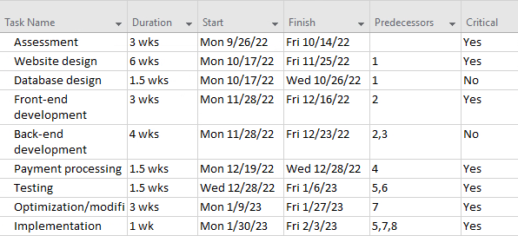

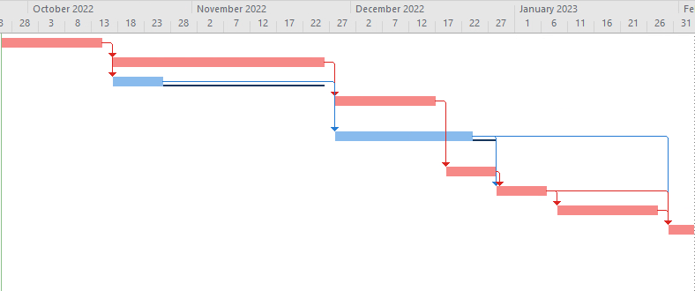

**PERT Chart:**

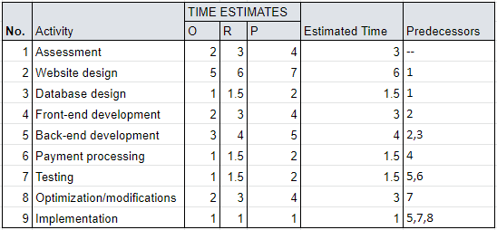

**PERT Diagram & Critical Path:**

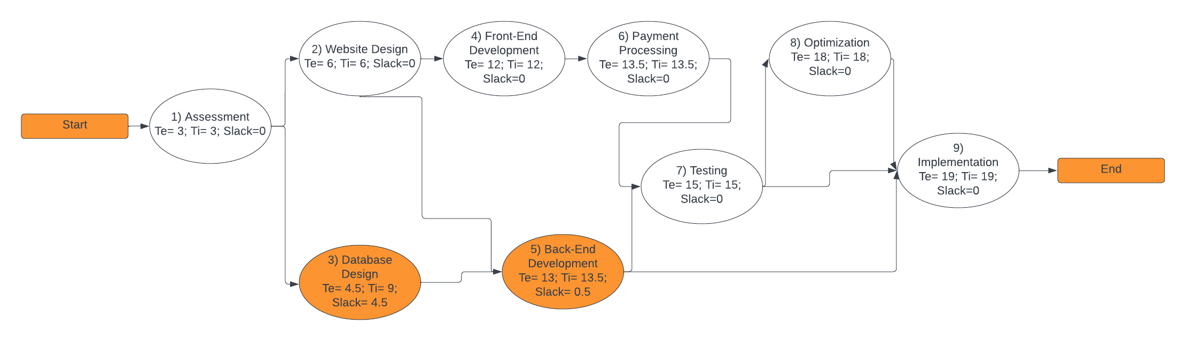

**Activity Slack Time:**

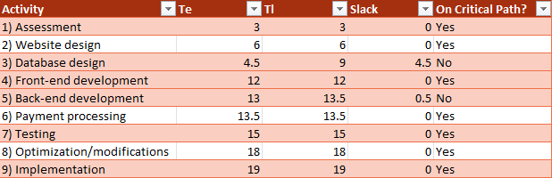

**Tangible Benefits**

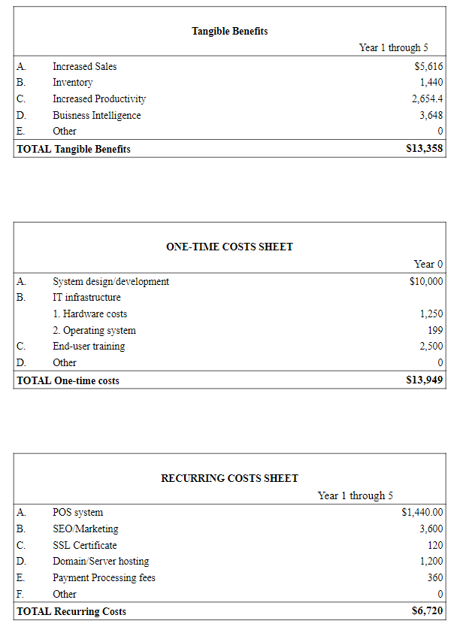

**Preliminary Budget**

Tangible Benefits include an increase in productivity, an overall increase in sales, and easier inventory management. One-time cost includes the system design, the IT (Information Technology) infrastructure (hardware and software). Reoccurring costs include the POS system software maintenance, the domain / server hosting for the website, and the payment processing fees when a card is used for a transaction. For more detailed information look in the **Economic Feasibility** section.

**Economic Feasibility Analysis**

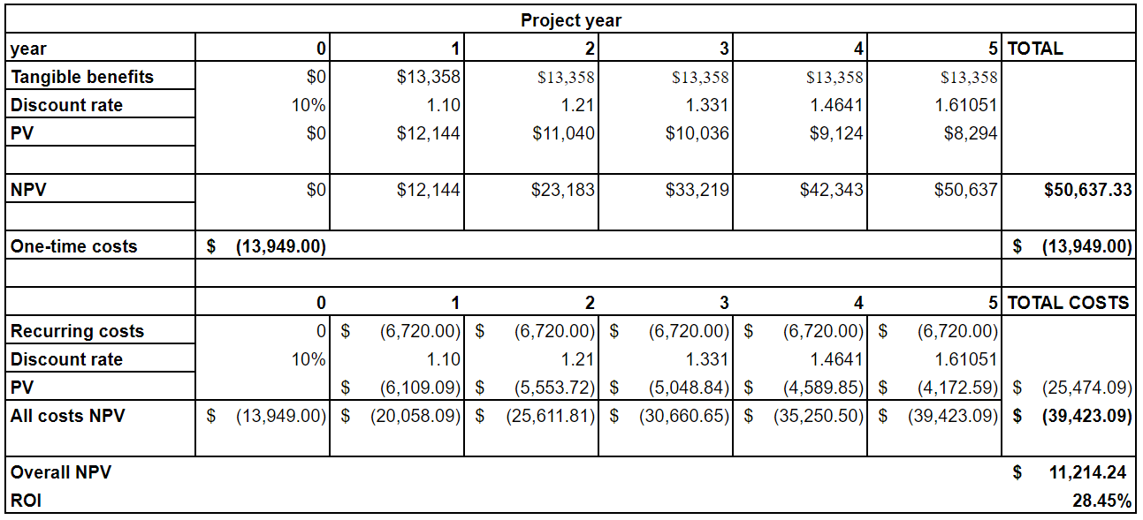

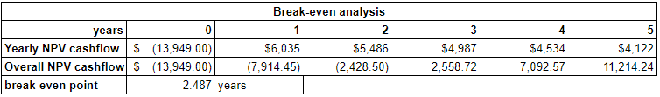

Break-even occurs on Saturday March 22nd, 2025

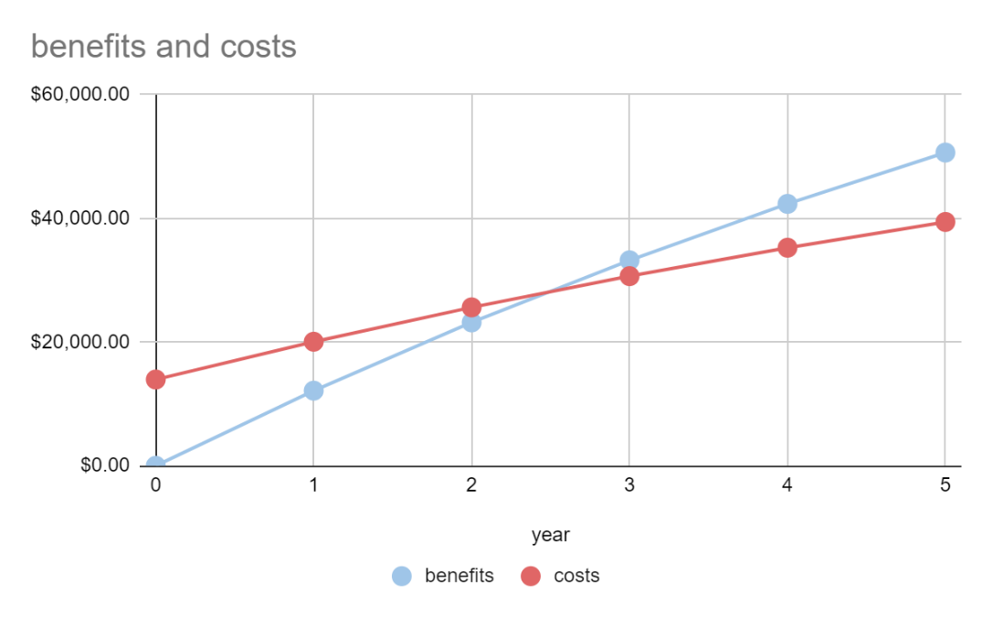

**Communication Plan**

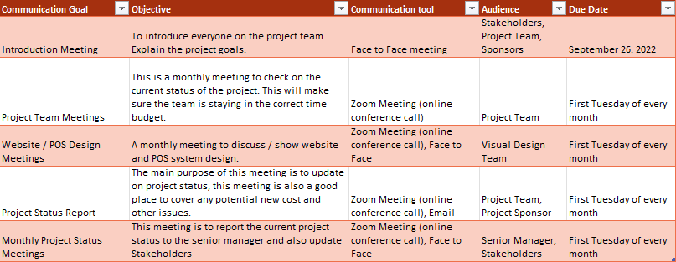

**Project Standards & Procedures**

To ensure that our online ordering process is simple, user-friendly, and works properly we will run a few test piolet days near the end of the project. A test piolet day will allow a limited number of orders for users to try our online ordering system. This information will be given to customers closer to the test piolet day and will provide feedback through the website after the order process is done. This information will then be collected and used to improve the website's usability and the system, ensuring the customer has a satisfactory experience.

**Identifying & Assessing Risk**

Risks have been identified for Double T’s Taverns’ new system and that is because sensitive customer information must be input to order online. The sensitive information that customers must provide is credit/debit card numbers, billing information, and first and last name. Processing information like this comes with security risk as if someone were to breach the system, they would have access to all that customers information. There are a few practical solutions to this problem which would be supporting end to end encryption for payment making the information unreadable or just having the customer pay at the restaurant through the POS system.

**Baseline Project Plan**

**Baseline Project Plan Report**

**Introduction**

**1. Project Overview –** The website for Double T’s Tavern is lacking in online ordering and services and detracts from potential online ordering and engagement with customers

**2. Recommendation –** To better stem the lost venue from online ordering, the team proposes an update to the website to add online ordering and menu browsing on the website with the option of adding a service tracker and contactless payment

**System Assessment**

**3. Alternative –** A potential alternative that could be implemented is a drive-in service that handles orders through a drive through. Another alternative is an app that can be used in the same fashion as ordering online through the website though this may require either partnering with an already established food delivery app or committing recourses to developing an app on their own

**4. System Description –** Establishing and maintaining a new online ordering system on the website would require monthly costs to keep them running effectively

**Feasibility Assessment**

**5. Economic Analysis –** An ordering system would give the project an ROI of 28.45%. The project would break-even within years 2 and 3. The Net Present Value of Costs would be $25,474.09 and the Net Present Value of Benefits would be $50,637.33.

**6. Technical Analysis –** Our analysis shows that the team are qualified and capable of writing up and completing this project

**7. Operational Analysis –** This system should help Double T’s Tavern to recapture the online market. Should this system be effectively implemented then it would produce more revenues for the business and increase the number of orders that would be in the system

**8. Legal and Contractual Analysis –** Double T’s Tavern is a sole proprietorship. This means there is negligible risk for this project going forward. The only issue that could arise would be using the customers’ credit card info, but this can easily be done away with a variety of options such as better security software or removing the user’s info after the food has been purchased, delivered, or picked up.

**9. Political Analysis –** The analysis projects that there should be little to no risk to it

**10. Schedules, Timeline, and Resource Analysis –** A working model of this project should be completed within February 2023 within approximately 4.75 months, give or take a few days. To complete this project effectively this team will need a project manager, system analyst, budget analyst, tracking, and the time to test and rework the system within Double T’s Tavern in collaboration with staff.

**Management Issues**

**11. Team Configuration/Management -** Andrew, Jensen, and Dylan will work in concert with one another to complete this project, dividing the work equal amongst us.

**12. Communication Plan:** This team created a group chat with each other to stay connected and help set up meetings hosted each week on Friday.

**13. Project Standards and Procedures –** Project milestones will be evaluated by the Project Sponsor i.e., Edward Chen. This milestone is subject to approval by the Project Sponsor

**Project Scope Statement**

Double T’s Tavern Prepared by Andrew Veloz, Dylan Gomes, Jensen Packard

Date: September 23, 2022

**General Project Information –** General Information about the project

*Project Name* Online Ordering System

*Sponsor* Adam Sandler

*Project Manager* Fabian Bradley

**Problem/Opportunity Statement –** Double T’s Tavern is in an excellent location that has high traffic for food, yet they lack online ordering causing them to lose out on potential customers. A system like this will increase traffic but also allow orders to be taken and processed more efficiently and accurately in and out of the restaurant.

**Project Objectives - This project's objective is to recapture and better serve the customer while increasing operation efficiency and accuracy.** Double T’s Tavern will be introducing and implementing a system to handle both online orders and in-restaurant operations.

**Project Description –** Creating a new Information System that will allow the customer to order online, pay with card, receive an order and payment confirmation, and support in store operations.

**Business Benefits**

Streamlined online/no contact to restaurant operations

Efficient ordering allows for a larger customer base and sales.

Minimizing human error which saves money due to less order mistakes.

**Deliverables –** At completion of this project Double T’s Tavern will receive a new Information System that increases restaurant operations and allows for online ordering. This system will be subject to approval of the Project Sponsor and submitted not later than the beginning of February 2023.

**Estimated Project Duration -**

4.75 Months

**User Requirements**

This system will enable the user to create online orders and receive messages on both the confirmation of their order and when it can be picked up or delivered. To utilize this system requires a few basic facets such as a smart device or a laptop of some kind along with internet connectivity to access the website. From there the user will be able to create and customize their order from the online menu on the website

* The system allows the user to create orders contactless
* The user will be able to review and confirm their orders in their cart and throughout the payment process
* The user can choose to pay with credit or with debit cards for online orders and dine in orders.
* Notifications will be sent out to the user on the confirmation of payment and when the order is ready

**System Requirements**

To create a website system, both hardware and software are required for the system.

1. **Hardware:**
   1. Displays/Monitors
   2. Keyboards
   3. Processors
   4. Memory cards
2. **Software:**
   1. System Software:
      1. Window/
      2. Linux/
      3. Mac OS
   2. Programming Software
      1. HTML
      2. Python
   3. Application Software:
      1. Microsoft Suite
      2. Internet Browsers

**Data Flow Diagrams**

1.1 Context Diagram

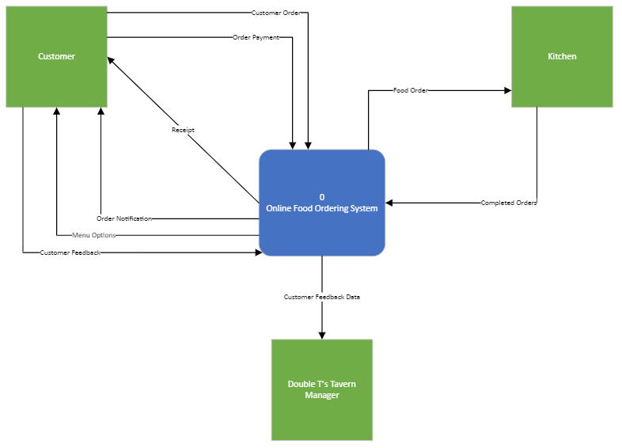

**Context Diagram**

Above is the Context Diagram for Double T’s Tavern’s Online Food Ordering System. There are multiple symbols used to complete the diagram, the dark blue square with rounded edges is for processes, the green squares are for data stores/sinks, and the black arrows are for data flows. The way the system works is first the customer will be able to view the menu options currently offered (“Menu Options”) and then place an order to the online food ordering system (“Customer Order”). The customer will then pay for their order (“Order Payment”), the system then sends the food order to the kitchen where it is prepared (“Food Order”) and sent back to the system when completed (“Completed Orders”). The customer will then receive a notification that their food is ready (“Order Notification”), once the customer picks up their order the system will send out a receipt to the customer (“Receipt”) and they will be able to provide feedback on the experience of using the system (“Customer Feedback”). This information is then sent from the system to Double T’s Tavern’s manager who can review the customer feedback information and use that to improve the system based on user feedback. The order information is also sent to the manager so they can see what products are selling well and can adjust the menu appropriately to sell the most product and make the most revenue possible (“Management report”).

**Level 0 Diagram**

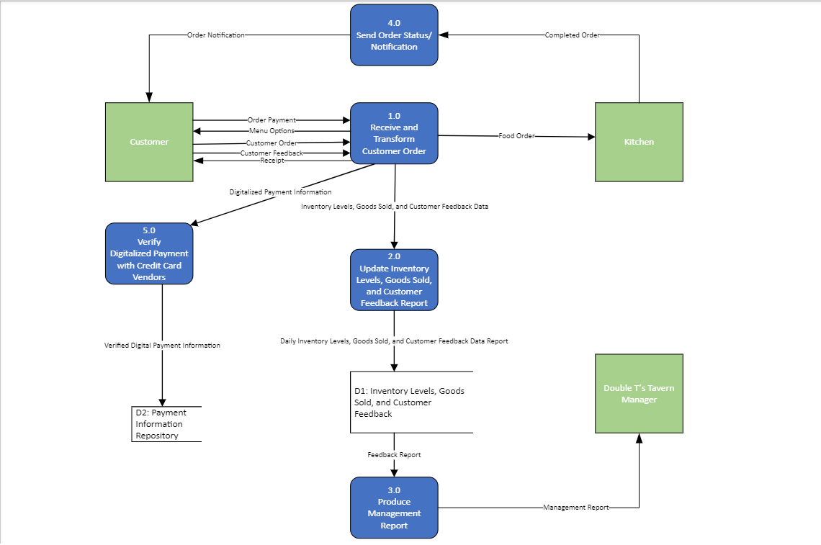 The level 0 diagram above uses the same symbols that were used in the context diagram, along with an additional data store symbol which is the black rectangles with the right side missing. The level 0 diagram is a decomposed version of the context diagram, and it even contains most of the same information as the context diagram. Customers will place orders, provide payment information, and provide feedback through the “Receive and Transform Customer Order” process. Then the kitchen receives the order and makes the food, once the food is completed then the Kitchen will “Send Order status/Notification” in either the Customer’s email or SMS. From this point the system will send information to the process “Update Inventory Levels, Goods Sold, and Customer Feedback Report” and move the data to the “Inventory Levels, Goods Sold, and Customer Feedback” data store, and that data gets inputted to “Produce Management Report”. The Digitized Payment Information is then sent to “Verify Digitalized Payment with Credit Card Vendor” which stores Verified Digital Payment Information in the “Payment Information Repository” data store. Once the Feedback Report data makes it to the “Produce Management Report”, it is then finally produced, and the “Management Report” is then sent to the “Double T’s Tavern Manager” for further review.

**Leveled Diagrams**

**Level 1 for Process 1.0**

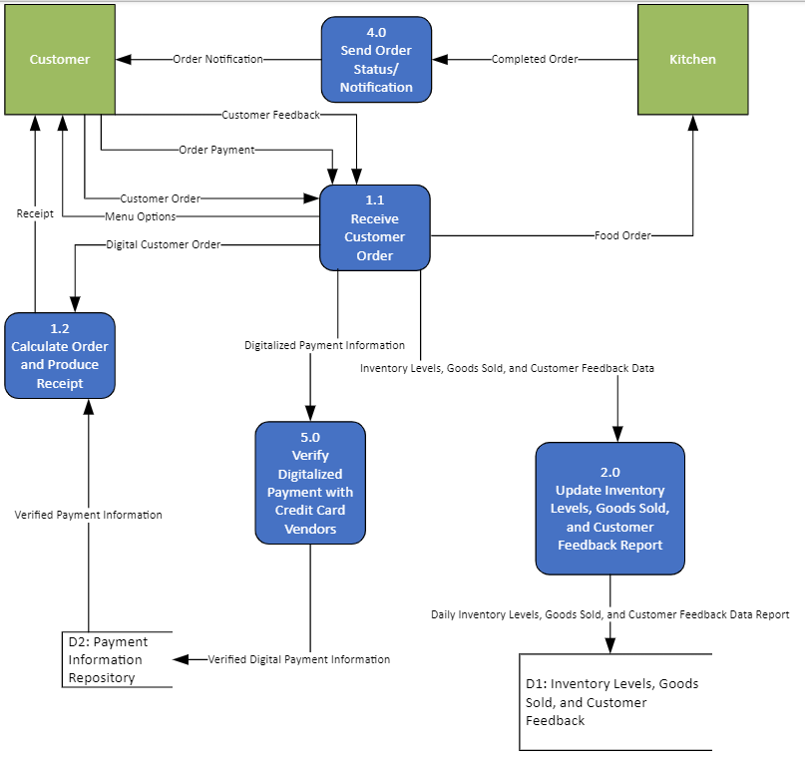

**Level 1 Diagram Showing Decomposition for Process 1.0**

The diagram above is the decomposition of Process 1.0: Receive Customer Order. The 1.1 process sends Menu Options to the Customer. In return, the Customer sends back their Customer Order, Order Payment, and Customer Feedback. The Customer Order is received and translated to a Food Order for going to the Kitchen. The Kitchen sends the Completed Order to Process 4.0: Send Order Status/Notification. Process 4.0 will then send an Order Notification to the Customer. In Process 1.2, a Digital Customer Order is provided from Process 1.1. Process 1.2: Calculate Order and Produce Receipt, sends a Receipt to the Customer. Process 1.1 produces Digital Payment Information, to be later verified in process 5.0: Verify Digitalized Payment with Credit Card Vendors which will send that Verified Digital Payment Information to be stored in the data store Payment Information Repository. Data store Payment Information Repository will then send Verified Payment Information to Process 1.2. Inventory Levels, Goods Sold, and Customer Feedback Data, are also sent from 1.1 to Process 2.0, Updating Inventory Levels, Goods Sold, and Customer Feedback Report. Finally, from Process 2.0 Daily Inventory Level, Goods Sold, and Customer Feedback Data Report is sent to the data store Inventory Levels, Goods Sold, and Customer Feedback.

**Level 1 for Process 2.0**

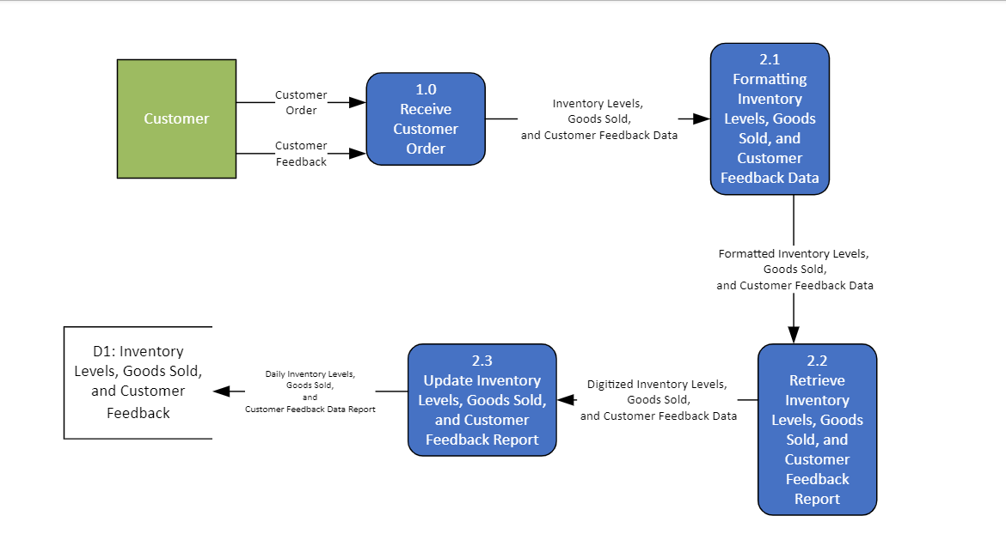

**Level 1 Diagram Showing Decomposition for Process 2.0**

Process 2.0 begins with the Customer, which provides the Customer order and Customer Feedback to Process 1.0. The Inventory levels, Goods Sold, and Customer Feedback data are processed into Process 2.1: Formatting Inventory Levels, Goods Sold, and Customer Feedback Data. Process 2.1 provides Formatted Inventory Levels, Goods Sold, and Customer Feedback data into process 2.2: Retrieve Inventory, Goods Sold, and Customer Feedback Report. This process digitizes the information and flows into Process 2.3. Update Inventory Levels, Goods Sold, and Customer Feedback Report. This is then sent out as the Daily Inventory Levels, Goods Sold, and Customer Feedback Data Report into the D1: Inventory Levels, Goods Sold, and Customer Feedback datastore.

**Level 1 for Process 3.0**

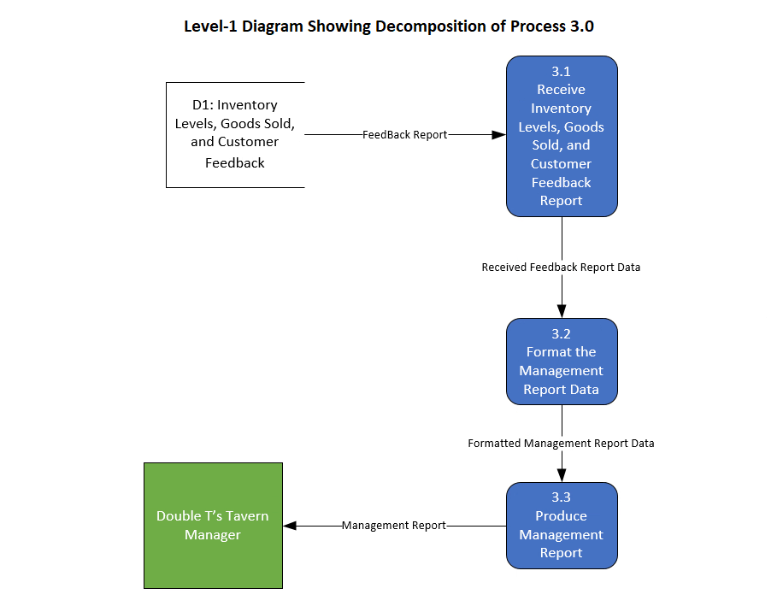

The breakdown for Process 3.0 begins with the Feedback Report retrieved from the D1 data store by 3.1 Receive Inventory Levels, Goods Sold, and Customer Feedback Report. This selected data is everything necessary for management reports. Process 3.1 relays the Received Feedback Report Data to be formatted in Process 3.2: Format the Management Report Data. This process formats the information into a Formatted Management Report Data which is then sent to Process 3.3: Produce Management Report. Process 3.3 then send Management Report out to Double T’ Tavern Manager.

**Level 1 for Process 5.0**

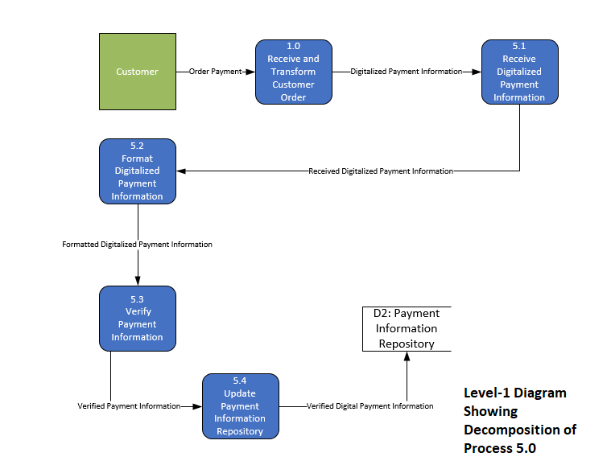

The decomposition of Process 5.0 starts with a customer as the source and provides the order payment. This payment information is received and transferred in Process 1.0, and the Digitalized Payment Information flows into Process 5.1: Receive Digitalized Payment information. Process 5.1 then sends out Received Digitalized Payment Information into Process 5.2: Format Digitalized Payment Information which then sends out Formatted Digitalized Payment Information to Process 5.3: Verify Payment Information for verification. Once verified, Process 5.3 sends Verified Payment Information to Process 5.4 Update Payment Information Repository. Process 5.4 updates the D2: Payment Information Repository data store with Verified Digital Payment information.

**Level 2 for Process 1.1**

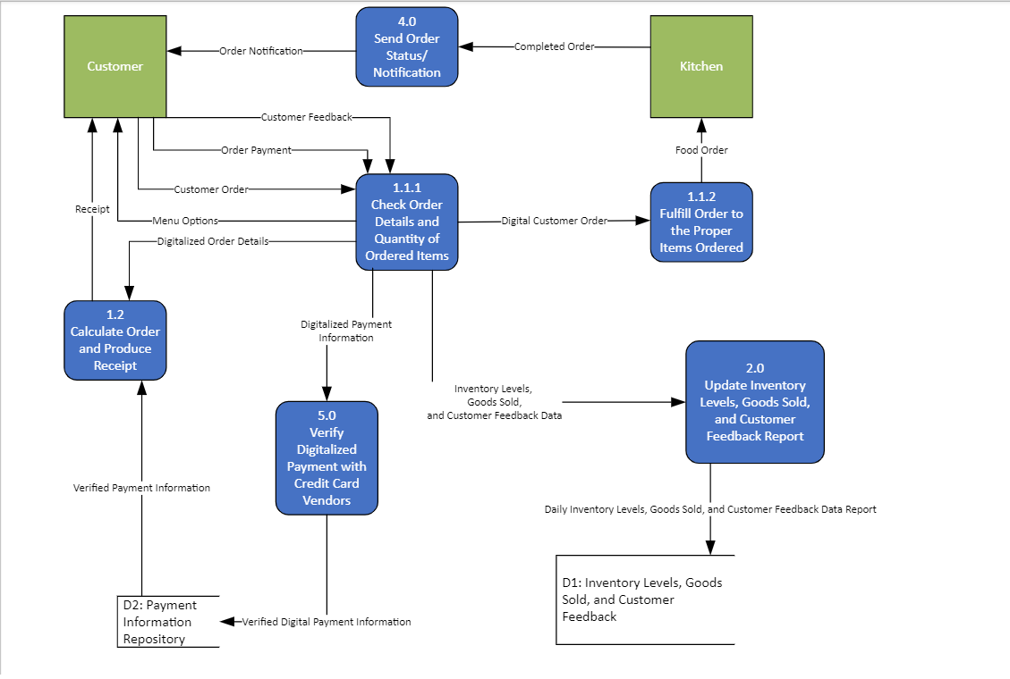

**Level 2 Diagram Showing Decomposition for Process 1.1**

The level 2 decomposition of process 1.1; Check Order Details and Quantity of Ordered Items. “Menu Options” is then sent to the customer, and supplies their order, as well as their payment, and customer feedback. The digital customer order is taken and converted into a food order for the Kitchen to prepare in process 1.1.2. The order details are kept producing a receipt after a verified payment is received. The digitized payment information is verified and stored in process 5.0. Then process 1.2 produces the receipt and sends it to the customer. In process 4.0, the kitchen sends a completed order, and an order notification is produced. Changes to inventory levels, goods sold, and customer feedback is kept updating Daily Inventory Levels, Goods Sold, and Customer Feedback Data Report. The D1: store receives updated information.

**Level 2 for Process 1.2**

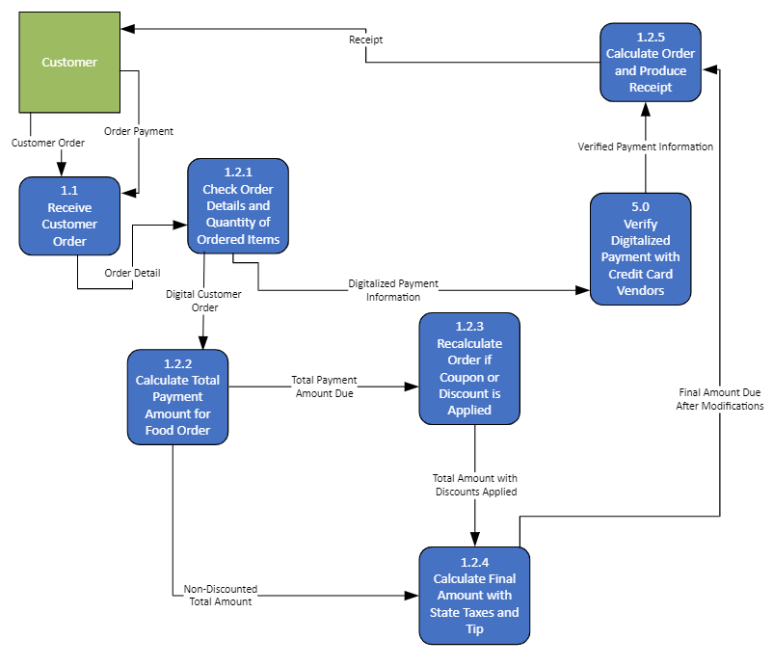

**Level 2 Diagram Showing Decomposition for Process 1.2**

Level 2 process 1.2 Decomposition. The customer produces an order and their order payment which is sent to the 1.1 process. The 1.1 Process then sends Order details to 1.2.1 process. The 1.2.1 process digitizes and sends the customer order to be used for payment totals and the receipt. The payment information flows to process 5.0, to be verified with card vendors. Discounts are recalculated if applied and are received in process 1.2.3. The total amount after discounts is then readjusted regarding taxes and potential tips. The final cost flows into process 1.2.5, and produces a receipt with the cost, and verified payment information. The customer lastly is sent their receipt from process 1.2.5. "Calculate Order and Produce Receipt"

**Primitive Data Flow Diagram**

The Primitive Data Flow Diagram is the lowest level of decomposition in a system. Since the Double T’s Tavern online ordering system is a fair amount complex, the Data Flow Diagram goes up to Level 2. Thus, there are 3 Major Source/Sinks and 5 Major Processes that interact with the system.

We were unable to decompose from the Level 0 data flow diagram Process 4.0: Send Order Status/Notification because they had already completed a single task. We were able to decompose from the level 1 and 2 data flow diagram Process 1.0: Receive and Transform Customer Order, Process 2.0: Update Inventory Levels, Goods Sold, and Customer Feedback Report, Process 3.0: Produce Management Report, and Process 5.0: Verifying Digitalized Payment with Credit Card Vendors. After we decomposed the system down to the level 2 diagram, there was no need to decompose further because they perform separate tasks. This means that the level 2 diagram is the lowest level Data Flow Diagram for Double T’s Tavern online ordering system

**Gap Analysis**

We performed a Gap Analysis on our system and found no discrepancies in the Data Flow Diagrams and ensured the Consistency and Integrity of the data flows and data stores

**Naming Standards for Processes**

Processes in the system are all denoted as blue squares with rounded edges. Each represents the procedures performed on certain data as they perform their actions throughout the system. The work performed is noted clearly on each symbol ensuring that all processes are executed to the data correctly.

The Process symbols include:

* The number of the Process,
  + Ex: “n.n” or “n.n.n”
* What the Process does,
  + Ex: “Action Verb & Noun Phrase”

Following the Data Flow Diagram Rules, the Process:

* No outputs only (miracles)
* No inputs only (blackholes
* Has one action verb phrase in the label

**Naming Standards for Data Flows**

The Data Flow Symbol is denoted as an arrow in the Data Flow Diagrams. The arrow shows how the data is moving in the system form one process, source/sink, or data store, to another. Each data flow is labeled with a unique name to represent the ever-changing data. The unique name is a noun in the middle of an arrow with no joining or forking lines in systems diagrams

**Data Consistency for Data Flows and Data Stores**

Consistency refers to the info from one level of a Data Flow Diagram that must be included in other levels. Each diagram includes the same data from the Level-0 diagram. D1: Inventory Levels, Goods Sold, and Customer Feedback, and D2: Payment Information Repository have also been included but not shown on the level 2 decomposition of Process 2.0.

**Data Miracles and Black Holes**

Double T’s Tavern’s online ordering system follows all data-flow diagramming rules. Processes are unable to have only outputs or only inputs i.e., miracles or blackholes. In the Context Diagram “Customer Order”, “Order Payment”, “Customer Feedback”, and “Completed Order” flow into the system, and “Order Notification”, “View Menu Options”, “Receipt”, “Management Report”, and “Food Order” flow out of the system

**Entity Relationship Diagrams**

Relationships and Cardinalities Explained

The Conceptual ER Diagram shown below is for Double T’s Taverns online ordering system. There are a total of 7 entities which are CUST_INFO, PAYMENT_INFO, RECEIPT, ORDER, MANAGEMENT, KITCHEN, and INVENTORY. All these entities each have their respective primary keys and foreign keys.

CUST_INFO has Cust_ID as its primary key

ORDER has Order_ID as its primary key and Cust_ID and Staff_ID as its foreign keys.

KITCHEN has Staff_ID as its primary key.

INVENTORY has Item_ID as its primary key and Staff_ID as its foreign key.

PAYMENT_INFO has Payment_ID as its primary key and Cust_ID as its foreign key.

RECEIPT has Transaction_ID as its primary key and Cust_ID and Order_ID as its foreign keys.

MANAGEMENT has Manager_ID as its primary key and Staff_ID as its foreign key.

Below are the explanations for all the two-way relationships:

1. CUST_INFO can place as many ORDERs as they want or no orders, but an ORDER is placed only by one CUST_INFO.
2. CUST_INFO can purchase their orders with only one PAYMENT_INFO. The PAYMENT_INFO is then connected to one and only one CUST_INFO.
3. CUST_INFO can receive only one RECEIPT per customer. A RECEIPT is received by one or more CUST_INFO (because multiple customers can get receipts).
4. An ORDER produces only one RECEIPT, and a RECEIPT is produced by one or more ORDERs (because each order gets a receipt).
5. ORDERs updates one or multiple items from INVENTORY, INVENTORY is updated for one or multiple ORDERs.
6. The KITCHEN can fulfill one or more ORDERs, An ORDER can be fulfilled by one or more KITCHEN staff.
7. The KITCHEN staff can report one or more files in INVENTORY, INVENTORY is reported by one or more KITCHEN staff.
8. MANAGERs can control one or more staff in the KITCHEN, The KITCHEN is controlled by only one single MANAGER.

**Conceptual Entity Relationship Diagrams**

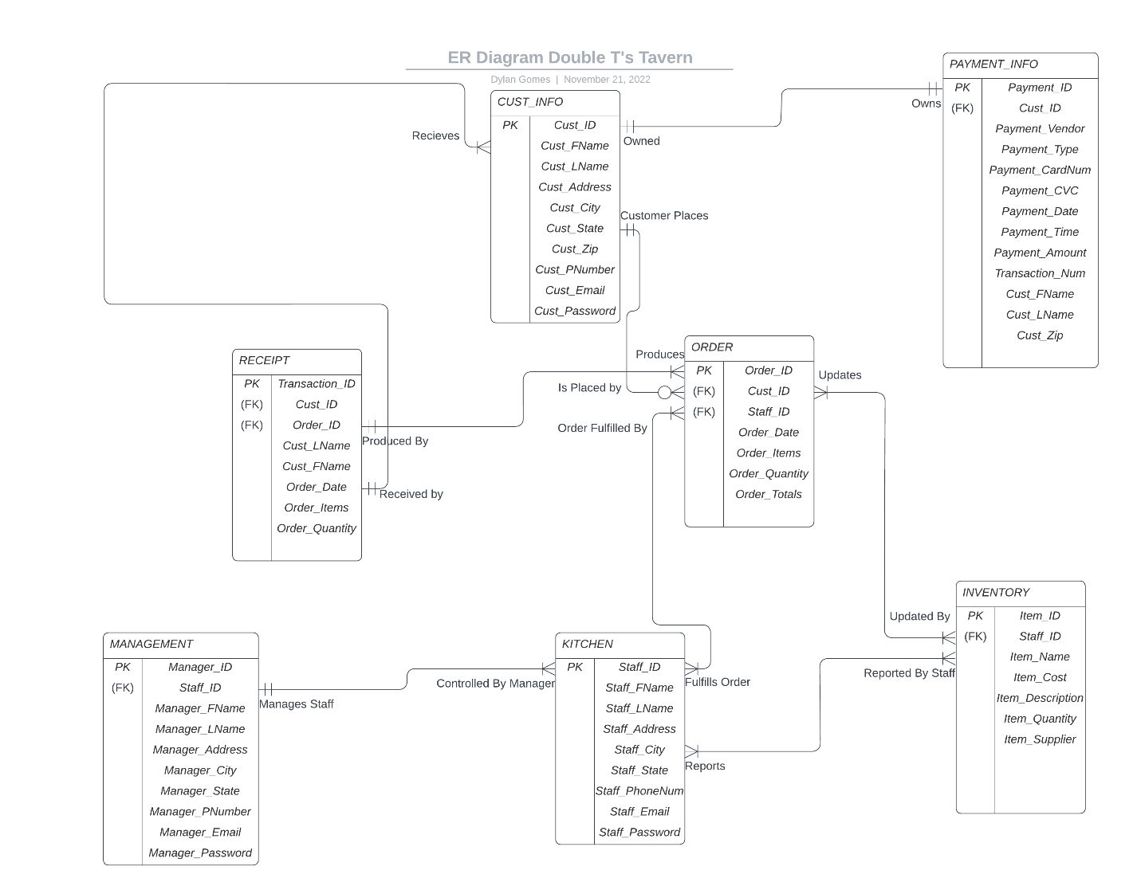

**Entity Relationships**

The ternary relationship between entities:

* CUST_INFO, RECEIPT, and ORDER are in a ternary relationship. The customer places the order, and once it is complete, it produces a receipt then sent back to the customer.
* ORDER, INVENTORY, and KITCHEN are in a ternary relationship. The order will check inventory levels to make sure we have the required items to complete the order. Once finished the items needed are sent to the kitchen and the order is fulfilled by staff so the final order can be invoiced and completed.

The binary relationship between entities:

* MANAGEMENT and KITCHEN have a binary relationship. Managers can oversee one or multiple employees, but an employee can only have one manager.
* CUST_INFO, PAYMENT_INFO has a binary relationship. A customer's payment information can only be associated with one customer (as a card is on a name and address basis).

**Data Dictionary**

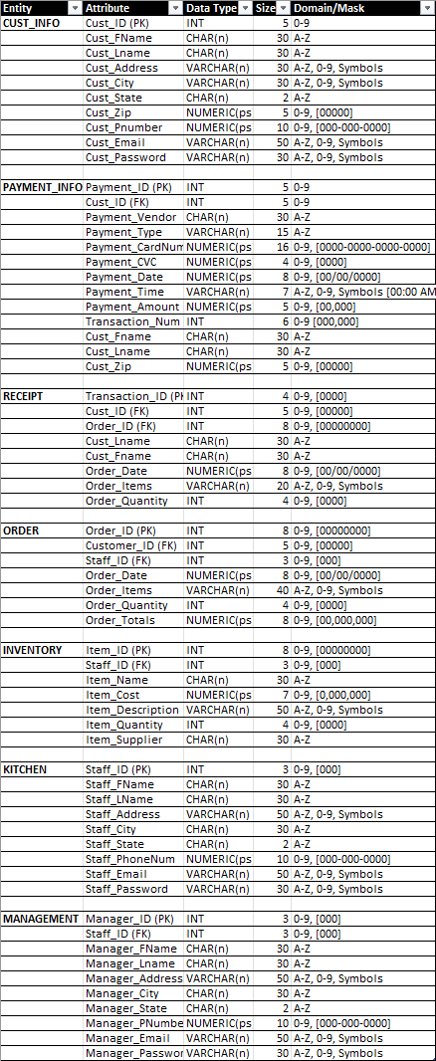

**Form and Report Designs**

**Specifications:**

|  |  |
| --- | --- |
| **Narrative Overview** | |
| **Form** | Homepage |
| **User** | Customer of Double T’s Tavern |
| **Task** | Allow customer to order food, contact restaurant, and learn more about them through their social media and About Us links |
| **System** | HTML |
| **Environment** | Double T’s Tavern |

**Sample Design:**

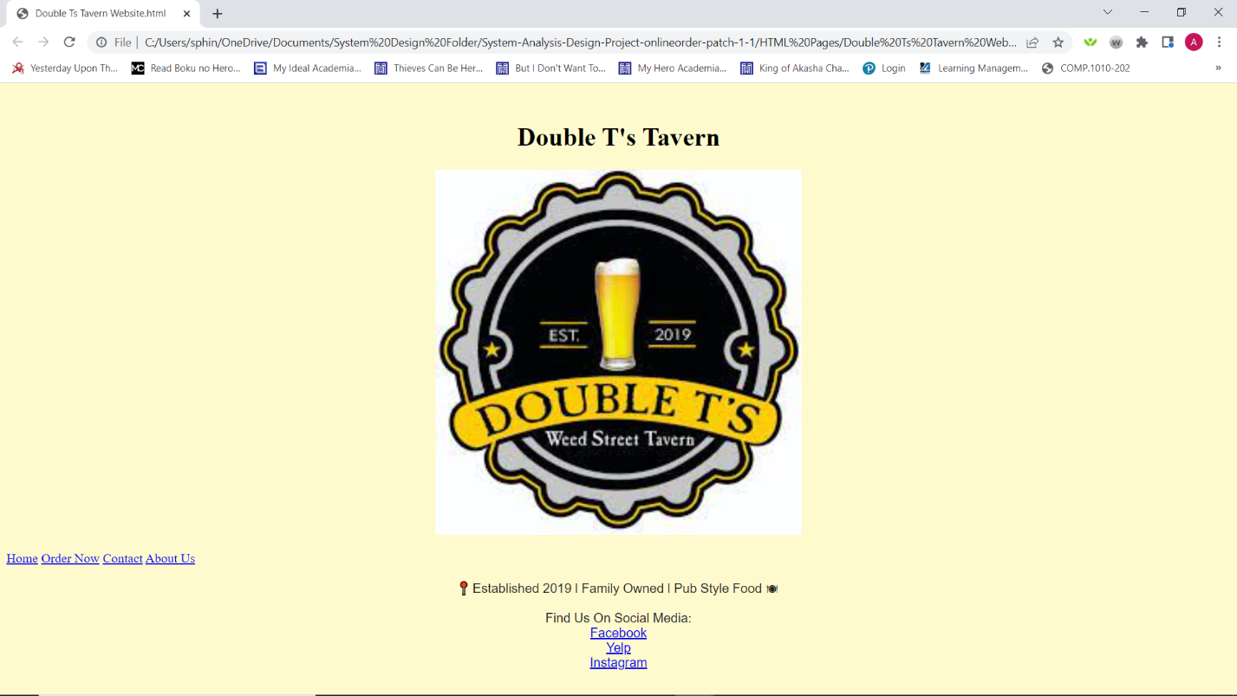

|  |
| --- |
| **Testing And Usability Assessment** |
| **Consistency (5 = Consistent and 1 = Inconsistent): 5** |
| **Sufficiency (5 = Sufficient and 1 = Insufficient): 4.5** |
| **Accuracy (5 = Accurate and 1 = Inaccurate): 5** |
| **Usability (5 = Ease of Use and 1 = Not User Friendly): 5** |

|  |  |
| --- | --- |
| **Narrative Overview** | |
| **Form** | About Us |
| **User** | Customer |
| **Task** | Introduce the customer more about Double T’s Tavern and its history |
| **System** | HTML |
| **Environment** | Double T’s Tavern |

**Sample Design:**

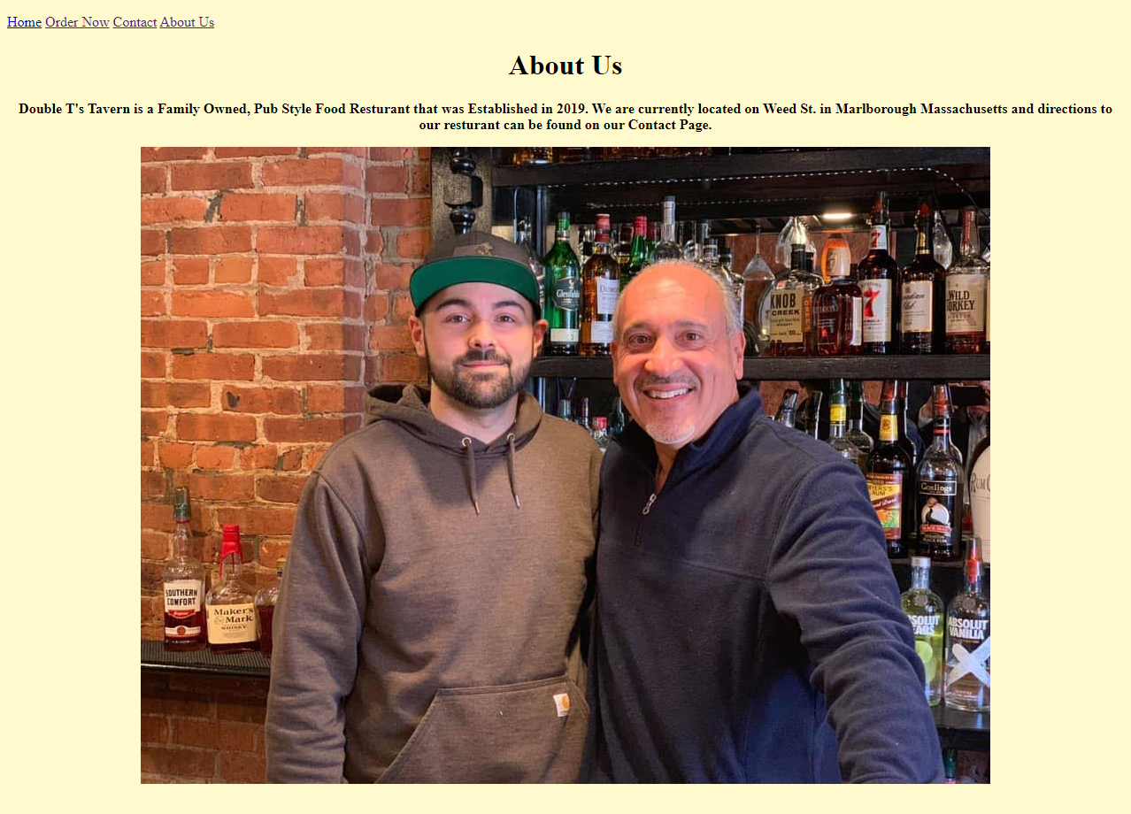

|  |
| --- |
| **Testing And Usability Assessment** |
| **Consistency (5 = Consistent and 1 = Inconsistent): 5** |
| **Sufficiency (5 = Sufficient and 1 = Insufficient): 4.5** |
| **Accuracy (5 = Accurate and 1 = Inaccurate): 5** |
| **Usability (5 = Ease of Use and 1 = Not User Friendly): 5** |

|  |  |
| --- | --- |
| **Narrative Overview** | |
| **Form** | Contact Us |
| **User** | Customer |
| **Task** | Give the user ways to contact Double T’s Tavern along with giving directions to their current location and giving information about their Business Hours |
| **System** | HTML |
| **Environment** | Double T’s Tavern |

**Sample Design:**

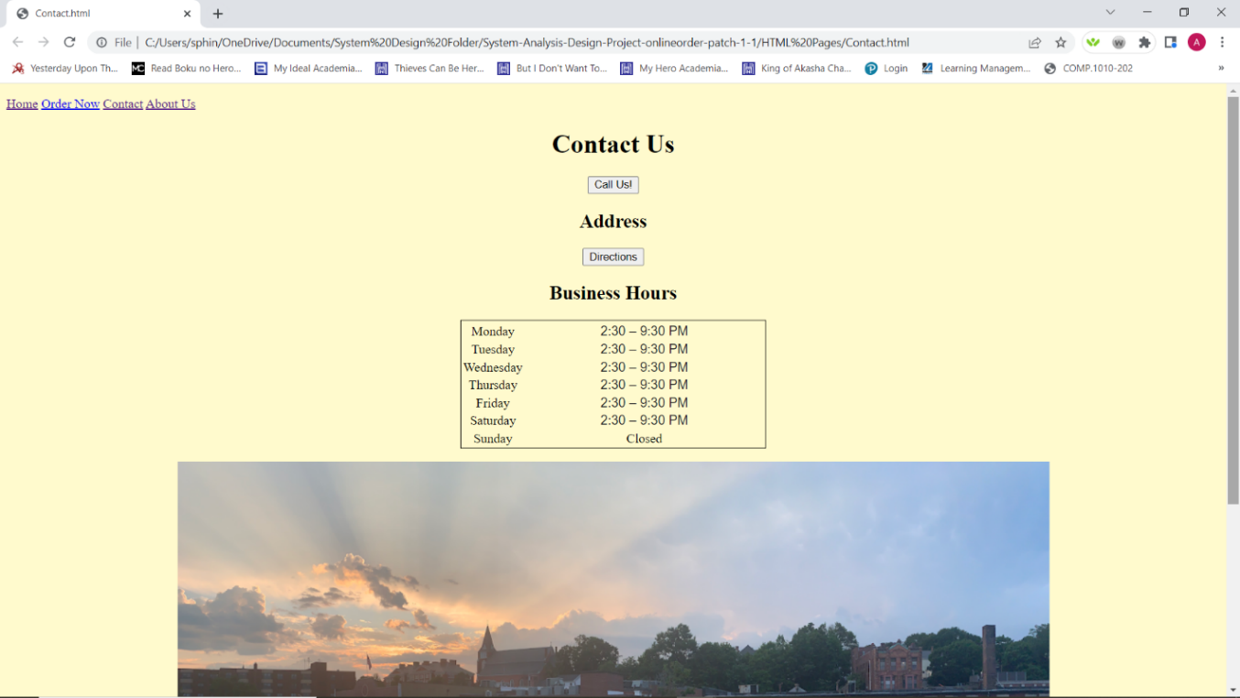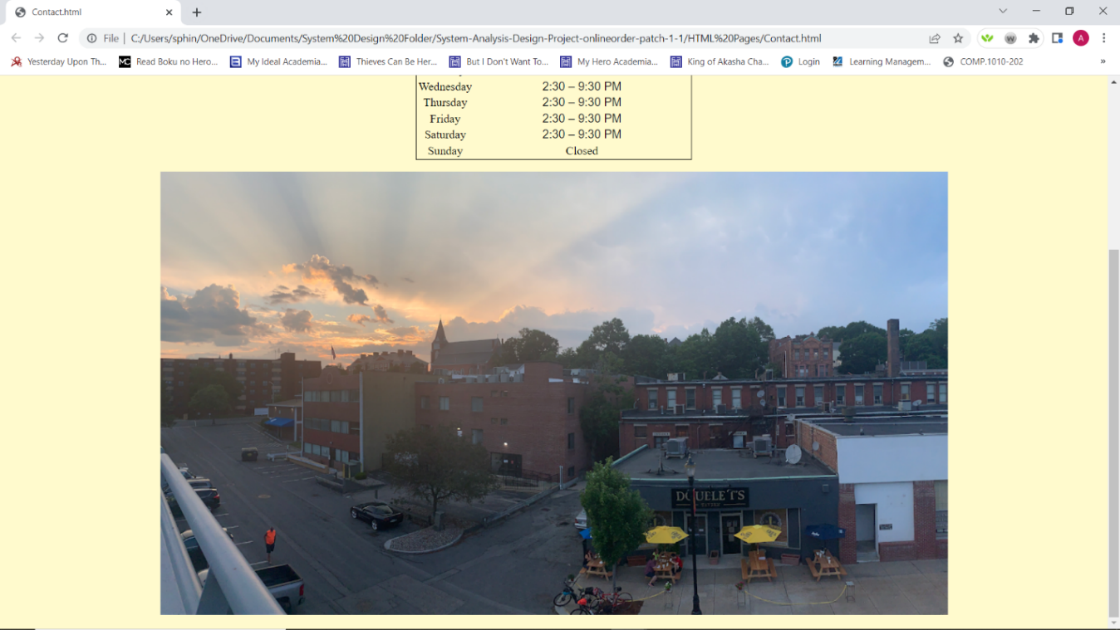

|  |
| --- |
| **Testing And Usability Assessment** |
| **Consistency (5 = Consistent and 1 = Inconsistent): 5** |
| **Sufficiency (5 = Sufficient and 1 = Insufficient): 5** |
| **Accuracy (5 = Accurate and 1 = Inaccurate): 5** |
| **Usability (5 = Ease of Use and 1 = Not User Friendly): 5** |

|  |  |
| --- | --- |
| **Narrative Overview** | |
| **Form** | Online Ordering Menu |
| **User** | Customer |
| **Task** | Online Ordering Menu displays Double T’s Tavern’s food and drink items where customers will be able to choose anything on the menu for their orders with the same prices as in the store |
| **System** | HTML |
| **Environment** | Double T’s Tavern |

**Sample Design:**

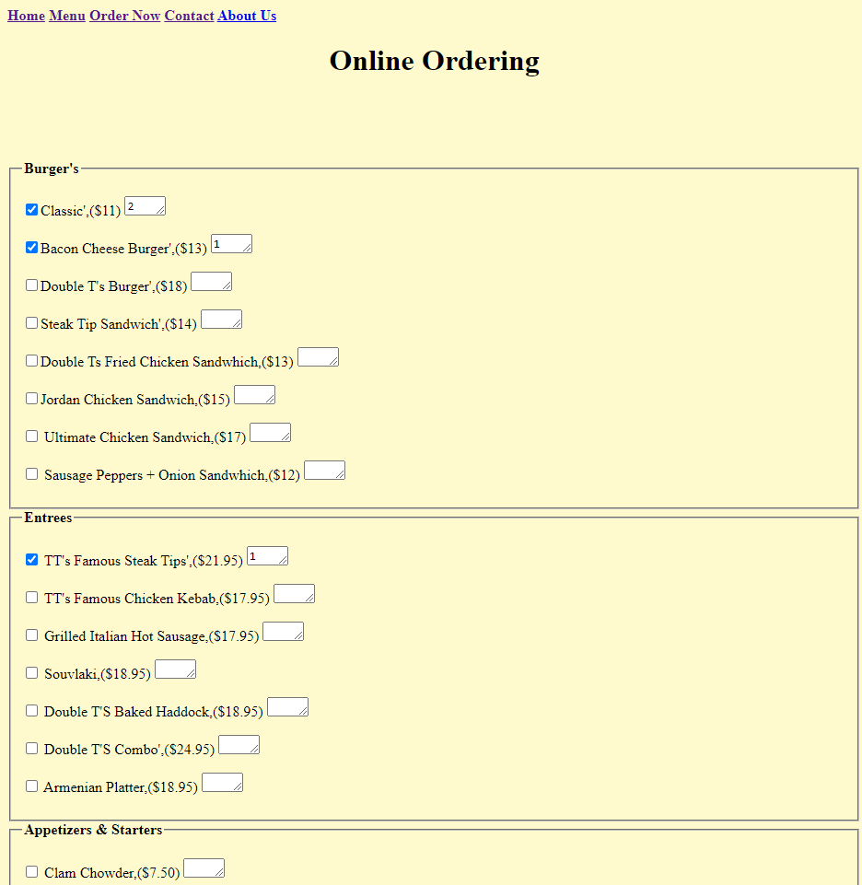

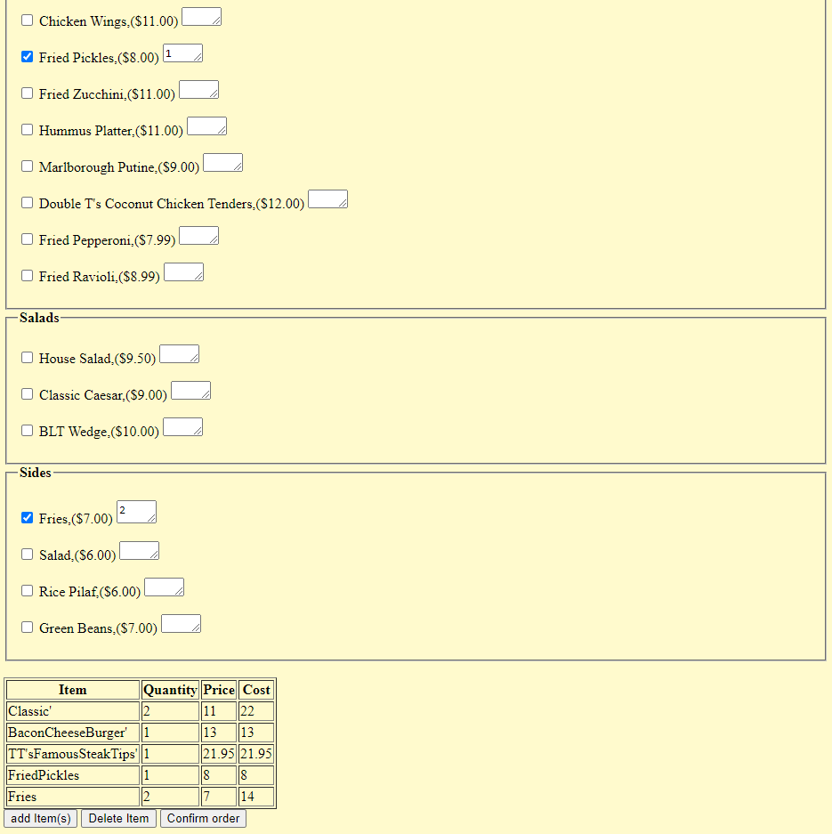

|  |
| --- |
| Testing And Usability Assessment |
| Consistency (5 = Consistent and 1 = Inconsistent): 5 |
| Sufficiency (5 = Sufficient and 1 = Insufficient): 5 |
| Accuracy (5 = Accurate and 1 = Inaccurate): 5 |
| Usability (5 = Ease of Use and 1 = Not User Friendly): 5 |

|  |  |
| --- | --- |
| **Narrative Overview** | |
| **Form** | Order Confirmation Message |
| **User** | Customer |
| **Task** | Confirm the customer’s order is in the system, take payment for the order in the cart, and allow for any feedback to be processed. |
| **System** | HTML |
| **Environment** | Double T’s Tavern |

**Sample Design:**

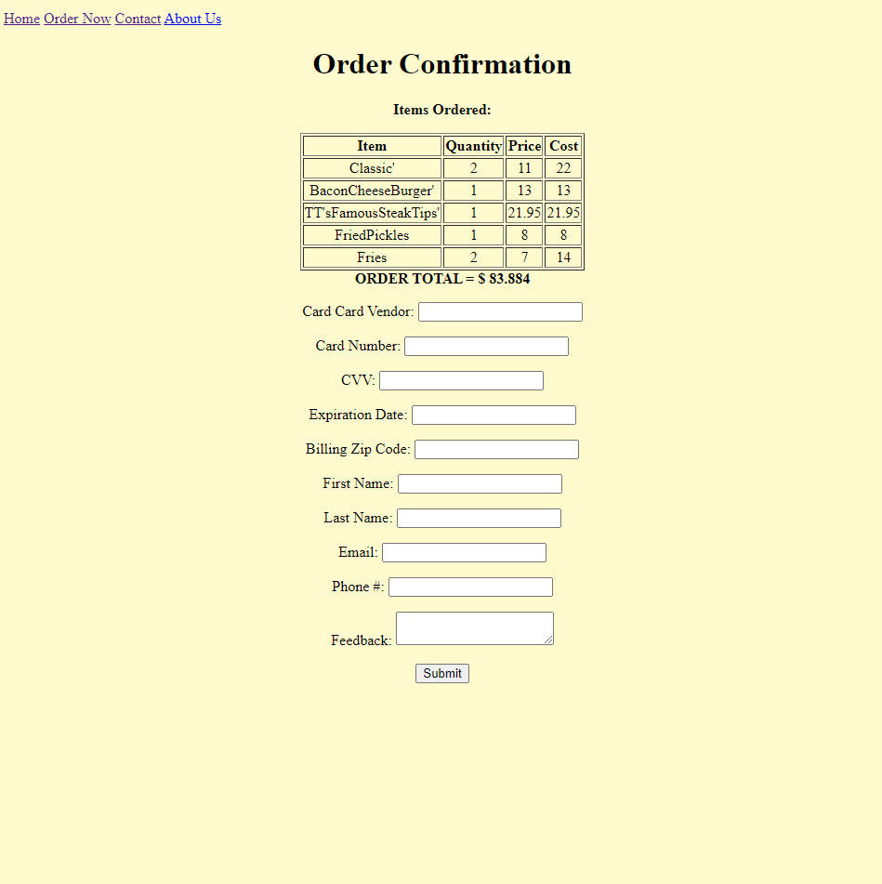

|  |
| --- |
| **Testing And Usability Assessment** |
| **Consistency (5 = Consistent and 1 = Inconsistent): 5** |
| **Sufficiency (5 = Sufficient and 1 = Insufficient): 4** |
| **Accuracy (5 = Accurate and 1 = Inaccurate): 5** |
| **Usability (5 = Ease of Use and 1 = Not User Friendly): 4** |

|  |  |
| --- | --- |
| **Narrative Overview** | |
| **Form** | Homepage for DB Access |
| **User** | Staff / Employees and Managers |
| **Task** | To allow each respective position to access the menu options they needed to add, edit, or remove information from the database. |
| **System** | Microsoft Access |
| **Environment** | Double Ts Tavern |

**Sample Design:** 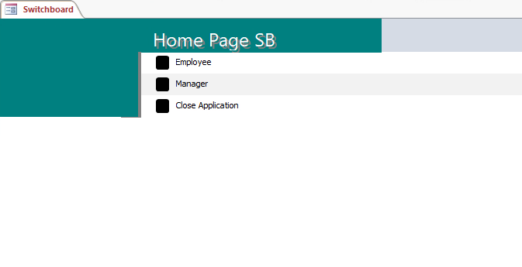

|  |
| --- |
| **Testing And Usability Assessment** |
| **Consistency (5 = Consistent and 1 = Inconsistent): 5** |
| **Sufficiency (5 = Sufficient and 1 = Insufficient): 5** |
| **Accuracy (5 = Accurate and 1 = Inaccurate): 5** |
| **Usability (5 = Ease of Use and 1 = Not User Friendly): 5** |

|  |  |
| --- | --- |
| **Narrative Overview** | |
| **Form** | Employee Database Access |
| **User** | Only for Staff / Employees |
| **Task** | To allow staff to add new customers, edit existing customer information, add orders, add receipts, and update inventory. |
| **System** | Microsoft Access |
| **Environment** | Double T’s Tavern |

**Sample Design:**

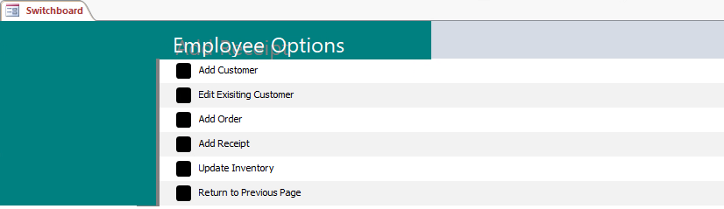

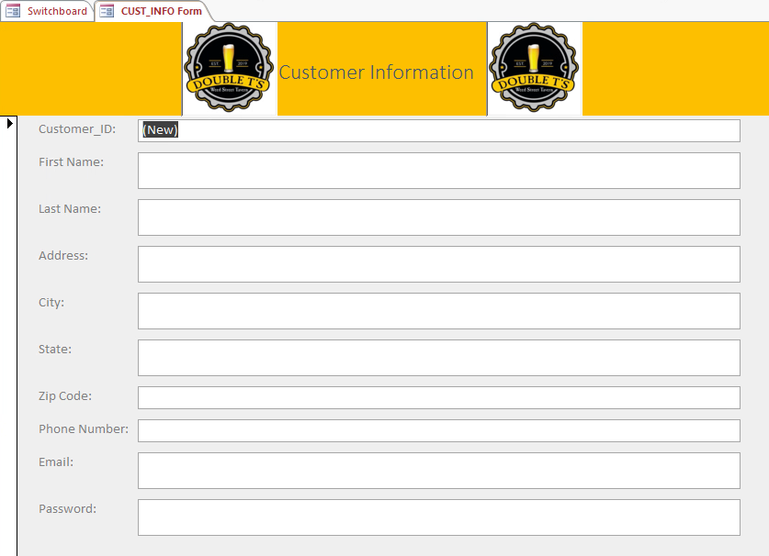

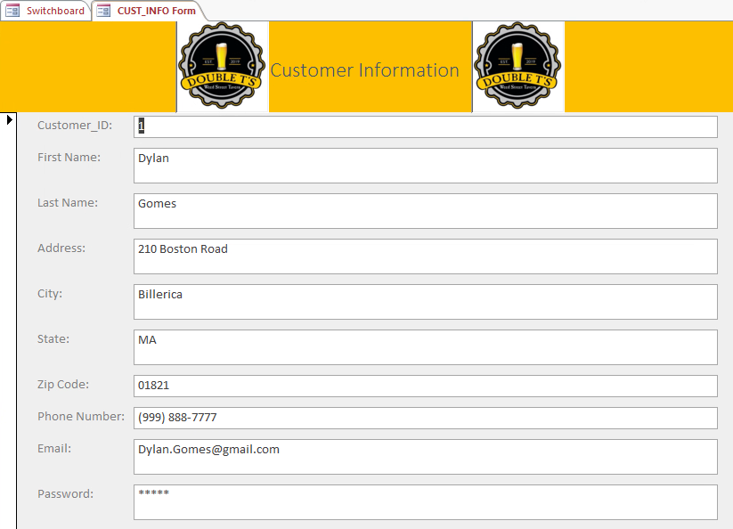

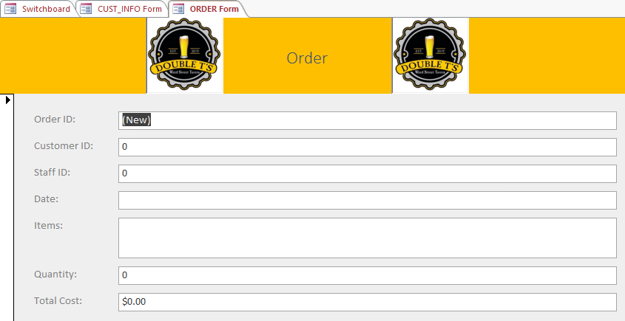

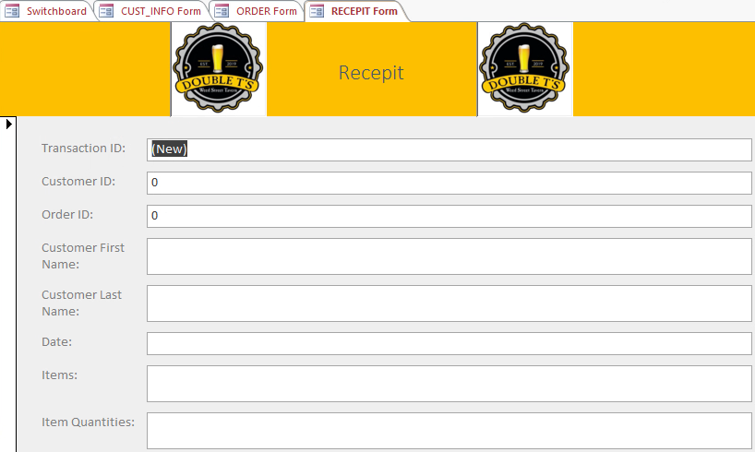

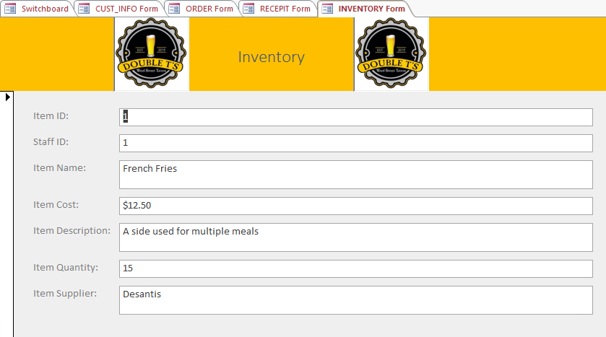

|  |
| --- |
| **Testing And Usability Assessment** |
| **Consistency (5 = Consistent and 1 = Inconsistent): 5** |
| **Sufficiency (5 = Sufficient and 1 = Insufficient): 5** |
| **Accuracy (5 = Accurate and 1 = Inaccurate): 5** |
| **Usability (5 = Ease of Use and 1 = Not User Friendly): 5** |

|  |  |
| --- | --- |
| **Narrative Overview** | |
| **Form** | Manager Database Access |
| **User** | Only Management |
| **Task** | To allow managers to add fresh staff, edit existing staff information, edit other managers, add inventory, and add payment. |
| **System** | Microsoft Access |
| **Environment** | Double T’s Tavern |

**Sample Design:**

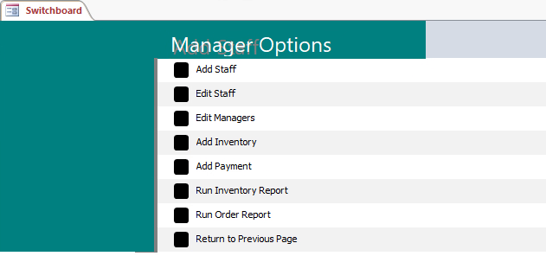

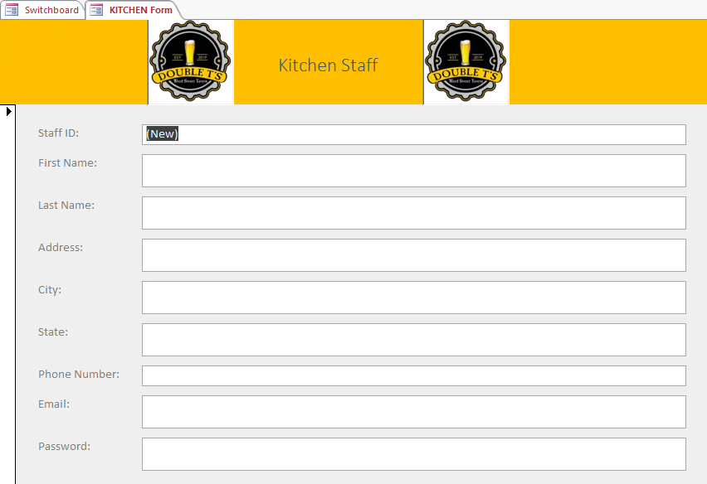

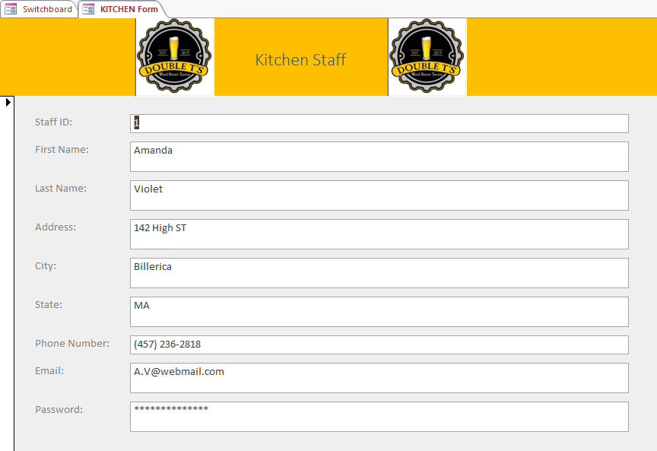

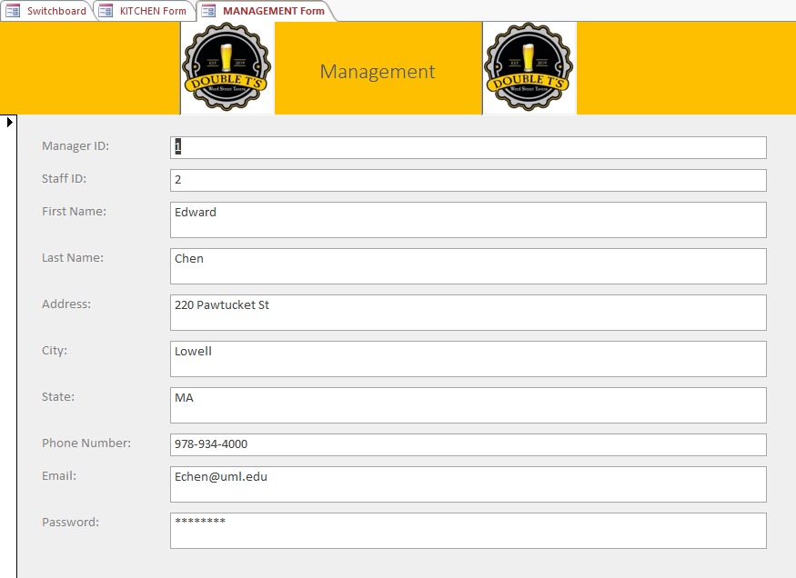

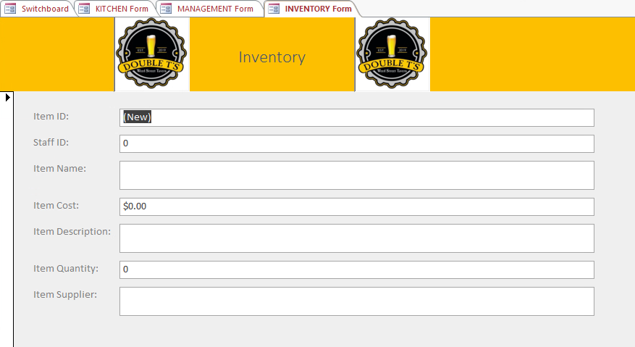

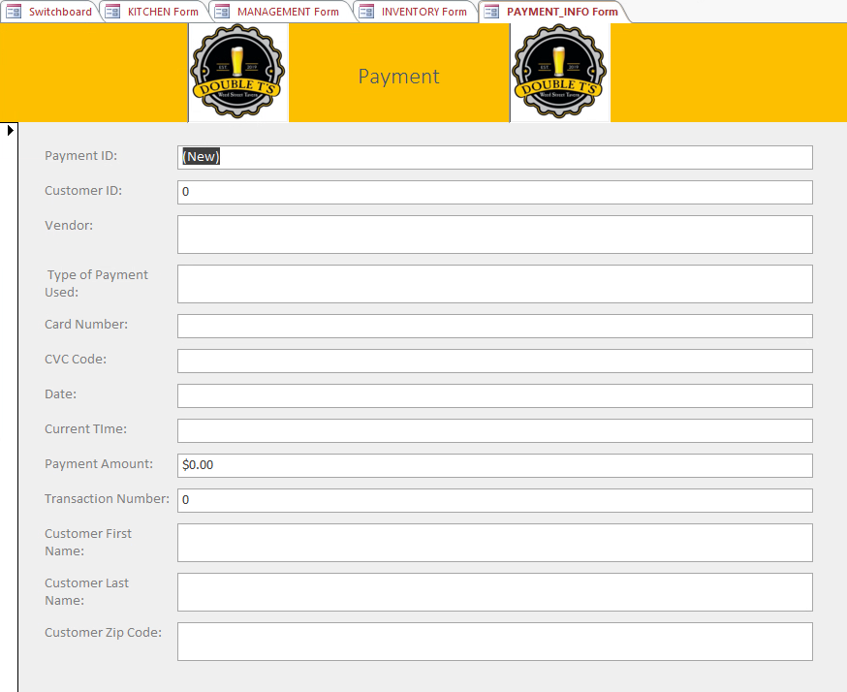

|  |
| --- |
| **Testing And Usability Assessment** |
| **Consistency (5 = Consistent and 1 = Inconsistent): 5** |
| **Sufficiency (5 = Sufficient and 1 = Insufficient): 5** |
| **Accuracy (5 = Accurate and 1 = Inaccurate): 5** |
| **Usability (5 = Ease of Use and 1 = Not User Friendly): 5** |

|  |  |
| --- | --- |
| **Narrative Overview** | |
| **Form** | Inventory and Order Reports |
| **User** | Management |
| **Task** | Allows managers to check inventory reports to see current inventory levels and the total amount of orders that have been made so far at Double Ts Tavern |
| **System** | Microsoft Access |
| **Environment** | Double T’s Tavern |

**Sample Design:**

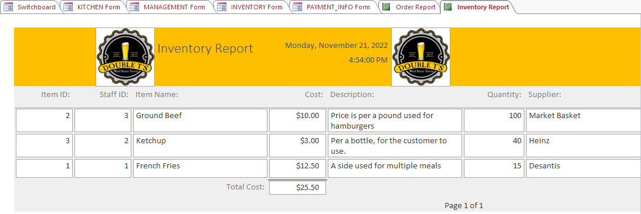

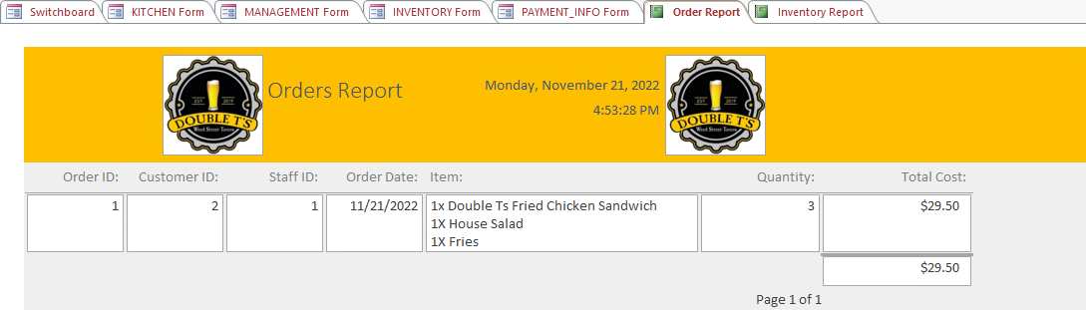

|  |
| --- |
| **Testing And Usability Assessment** |
| **Consistency (5 = Consistent and 1 = Inconsistent): 5** |
| **Sufficiency (5 = Sufficient and 1 = Insufficient): 5** |
| **Accuracy (5 = Accurate and 1 = Inaccurate): 5** |
| **Usability (5 = Ease of Use and 1 = Not User Friendly): 5** |

**Interface and Dialogue Design**

**Specifications-Deliverables and Outcomes**

**Website**

**Narrative Overview**

**Interface/Dialogue:** Online Ordering Menu

**User Characteristics:** Customer with access to an internet device

**Task Characteristics:** allows users to select which items they want off the menu and what

quantity they want of those items

**System Characteristics:** Must run on an internet application

**Environmental Characteristics:** Device with internet access

**Interface/Dialogue Design**

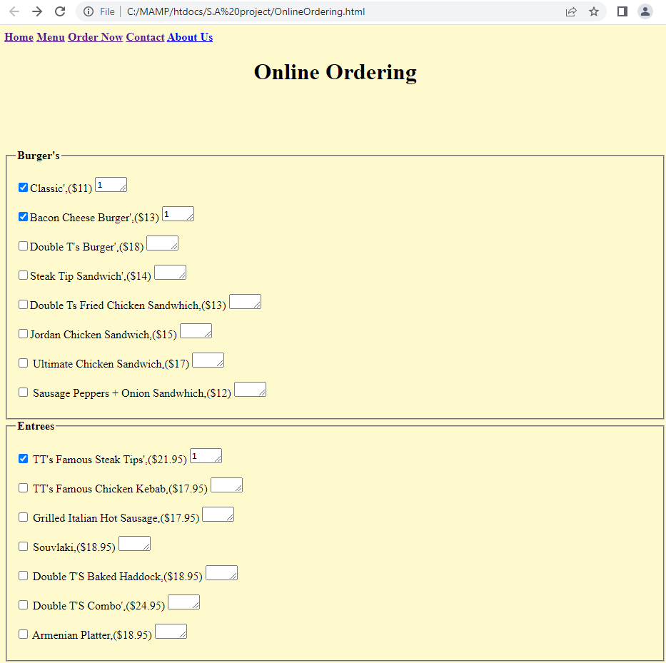

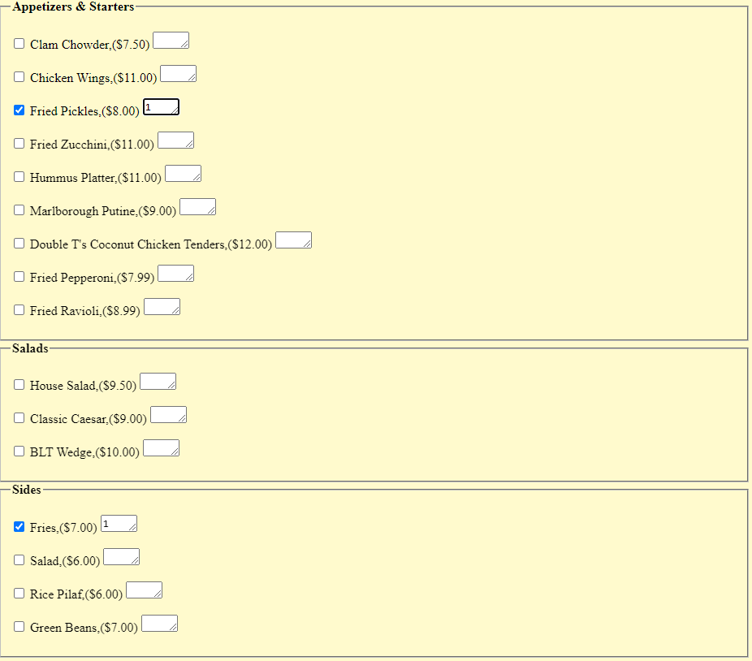

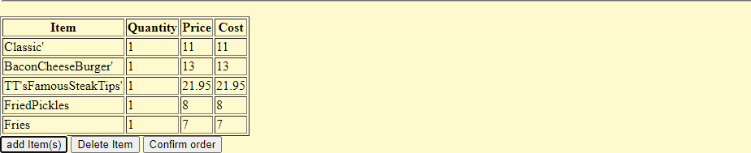

**Testing and Usability Assessment**

**Testing Objective:** to make sure the user can select items off the menu and put a specific

quantity for that item.

**Testing Procedure:** select menu items and input quantities for those items

**Testing Results:** 0 errors

**Database:**

**Narrative Overview**

**Interface/Dialogue:** Home Page SB

**User Characteristics:** employees and managers with Microsoft Access

**Task Characteristics:** allows employees and managers to input information into the database

**System Characteristics:** Must run on a Microsoft Access

**Environmental Characteristics:** Device with Microsoft Access



**Testing and Usability Assessment**

**Testing Objective:** to make sure the user is brought to the right place on the database. The

employee will only be able to go into the Employee menu and the manager will have access to

both the Employee and Manager menu.

**Testing Procedure:** select items to test to see if they bring the user to the correct area

**Testing Results:** 0 errors

**Narrative Overview**

**Interface/Dialogue:** Employee Menu

**User Characteristics:** employees and managers with Microsoft Access

**Task Characteristics:** allows employees and managers to input information into the database

**System Characteristics:** Must run on a Microsoft Access

**Environmental Characteristics:** Device with Microsoft Access



**Testing and Usability Assessment**

**Testing Objective:** to make sure the user is brought to the right place on the database. The

employee should only be able to click on “Add Customer”, “Edit Existing Customer”, “Add Order”, “Add Receipt”, “Update Inventory”, and “Return to Previous Page”

**Testing Procedure:** select items to test to see if they bring the user to the correct area

**Testing Results:** 0 errors

**Narrative Overview**

**Interface/Dialogue:** Add/Edit Customer

**User Characteristics:** employees and managers with Microsoft Access

**Task Characteristics:** allows employees and managers to input information into the database

**System Characteristics:** Must run on a Microsoft Access

**Environmental Characteristics: Device with Microsoft Access**



**Testing and Usability Assessment**

**Testing Objective:** to make sure the user is brought to either “Add Customer” or “Edit Existing

Customer” (same form, different buttons).

**Testing Procedure:** select items to test to see if they bring the user to the correct area

**Testing Results:** 0 errors

**Narrative Overview**

**Interface/Dialogue:** Add Order

**User Characteristics:** employees and managers with Microsoft Access

**Task Characteristics:** allows employees and managers to input information into the database

**System Characteristics:** Must run on a Microsoft Access

**Environmental Characteristics:** Device with Microsoft Access

**Testing and Usability Assessment**

**Testing Objective:** to make sure the user is brought “Add Order”.

**Testing Procedure:** select items to test to see if they bring the user to the correct area

**Testing Results:** 0 errors

**Narrative Overview**

**Interface/Dialogue:** Add Receipt

**User Characteristics:** employees and managers with Microsoft Access

**Task Characteristics:** allows employees and managers to input information into the database

**System Characteristics:** Must run on a Microsoft Access

**Environmental Characteristics:** Device with Microsoft Access

**Testing and Usability Assessment**

**Testing Objective:** to make sure the user is brought “Add Receipt”.

**Testing Procedure:** select items to test to see if they bring the user to the correct area

**Testing Results:** 0 errors

**Narrative Overview**

**Interface/Dialogue:** Update Inventory

**User Characteristics:** employees and managers with Microsoft Access

**Task Characteristics:** allows managers to input information into the database

**System Characteristics:** Must run on a Microsoft Access

**Environmental Characteristics:** Device with Microsoft Access



**Testing and Usability Assessment**

**Testing Objective:** to make sure the user is brought to “Add Inventory”

**Testing Procedure:** select items to test to see if they bring the user to the correct area

**Testing Results:** 0 errors

**Narrative Overview**

**Interface/Dialogue:** Manager Menu

**User Characteristics:** employees and managers with Microsoft Access

**Task Characteristics:** allows managers to input information into the database

**System Characteristics:** Must run on a Microsoft Access

**Environmental Characteristics:** Device with Microsoft Access



**Testing and Usability Assessment**

**Testing Objective:** to make sure the user is brought to the right place on the database. The

employee should only be able to click on “Add Staff”, “Edit Staff”, “Edit Managers”, “Add Inventory”, “Add Payment”, “Run Inventory Report”, “Run Order Report”, and “Return to Previous Page”

Testing Procedure: select items to test to see if they bring the user to the correct area

Testing Results: 0 errors

**Narrative Overview**

**Interface/Dialogue:** Add/Update Employee

**User Characteristics:** employees and managers with Microsoft Access

**Task Characteristics:** allows managers to input information into the database

**System Characteristics:** Must run on a Microsoft Access

**Environmental Characteristics:** Device with Microsoft Access



**Testing and Usability Assessment**

**Testing Objective:** to make sure the user is brought to “Add Staff” and “Edit Staff”, since they are the same form, different buttons.

**Testing Procedure:** select items to test to see if they bring the user to the correct area

**Testing Results:** 0 errors

**Narrative Overview**

**Interface/Dialogue:** Edit Manager

**User Characteristics:** employees and managers with Microsoft Access

**Task Characteristics:** allows managers to input information into the database

**System Characteristics:** Must run on a Microsoft Access

**Environmental Characteristics:** Device with Microsoft Access



**Testing and Usability Assessment**

**Testing Objective:** to make sure the user is brought to “Edit Manager”

**Testing Procedure:** select items to test to see if they bring the user to the correct area

**Testing Results:** 0 errors

**Narrative Overview**

**Interface/Dialogue:** Add Inventory

**User Characteristics:** employees and managers with Microsoft Access

**Task Characteristics:** allows managers to input information into the database

**System Characteristics:** Must run on a Microsoft Access

**Environmental Characteristics:** Device with Microsoft Access



**Testing and Usability Assessment**

**Testing Objective:** to make sure the user is brought to “Add Inventory”

**Testing Procedure:** select items to test to see if they bring the user to the correct area

**Testing Results:** 0 errors

**Narrative Overview**

**Interface/Dialogue:** Add Payment

**User Characteristics:** employees and managers with Microsoft Access

**Task Characteristics:** allows managers to input information into the database

**System Characteristics:** Must run on a Microsoft Access

**Environmental Characteristics:** Device with Microsoft Access



**Testing and Usability Assessment**

**Testing Objective:** to make sure the user is brought to “Add Payment”

**Testing Procedure:** select items to test to see if they bring the user to the correct area

**Testing Results:** 0 errors

**Narrative Overview**

**Interface/Dialogue:** Run Inventory Report

**User Characteristics:** Managers with Microsoft Access

**Task Characteristics:** allows managers to input information into the database

**System Characteristics:** Must run on a Microsoft Access

**Environmental Characteristics:** Device with Microsoft Access



**Testing and Usability Assessment**

**Testing Objective:** to make sure the user is brought to “Run Inventory Report”, and it is showing the correct information

**Testing Procedure:** select items to test to see if they bring the user to the correct area

**Testing Results:** 0 errors

**Narrative Overview**

**Interface/Dialogue:** Run Order Report

**User Characteristics:** Managers with Microsoft Access

**Task Characteristics:** allows managers to input information into the database

**System Characteristics:** Must run on a Microsoft Access

**Environmental Characteristics:** Device with Microsoft Access



**Testing and Usability Assessment**

**Testing Objective:** to make sure the user is brought to “Run Order Report”, and it is showing the correct information

**Testing Procedure:** select items to test to see if they bring the user to the correct area

**Testing Results:** 0 errors

**Guidelines**

**Design the Dialogue Sequence Diagram**

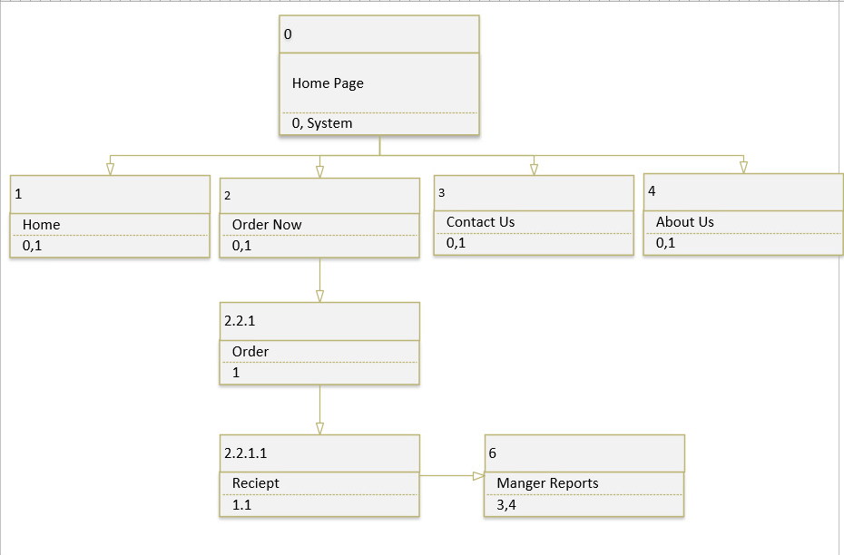

**Documentation**

**User Manual**

This is our step-by-step user guide to the Double T’s Tavern Ordering system.

**Double T’s Tavern Website**

**Step 1:** The user will access the Double T’s Tavern website by going to [www.doubletstavern.net](http://www.doubletstavern.net), which when you go to it brings you to the homepage of the website. On the homepage you will see the company logo, a little information about our company, and where to find us on social media.



**Step 2: After** the user explores the homepage, they can then select the order now page. At the middle left of the page, this will allow the user to see what food items we have on our menu, along with the options to add items, delete items, and confirm the order once they are ready.

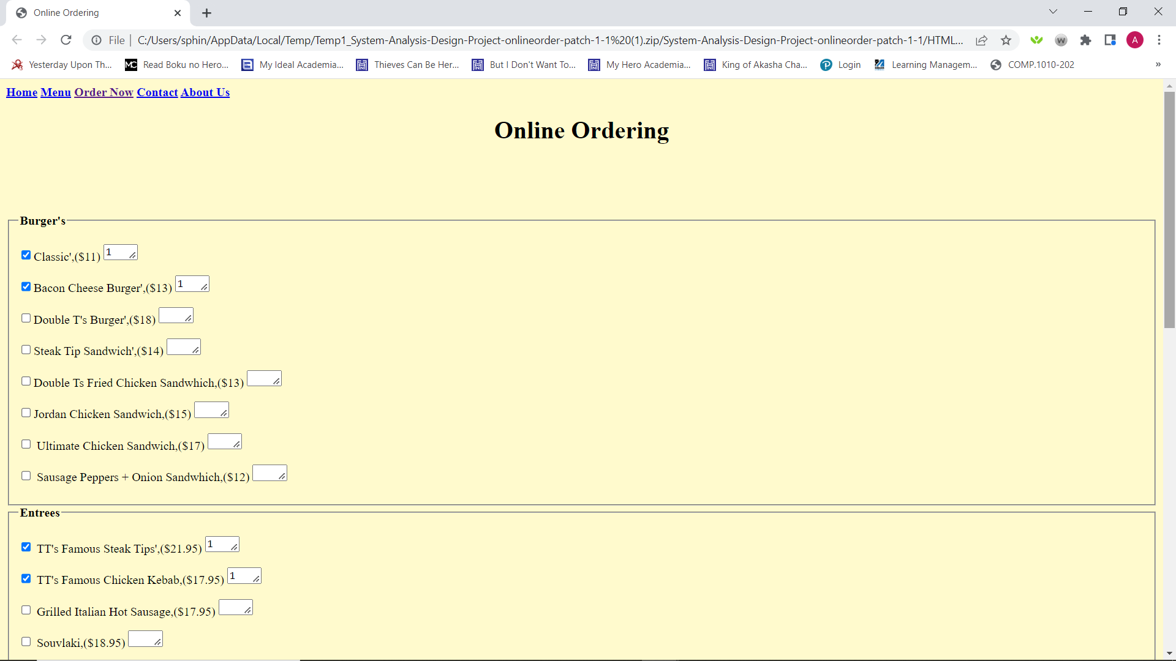

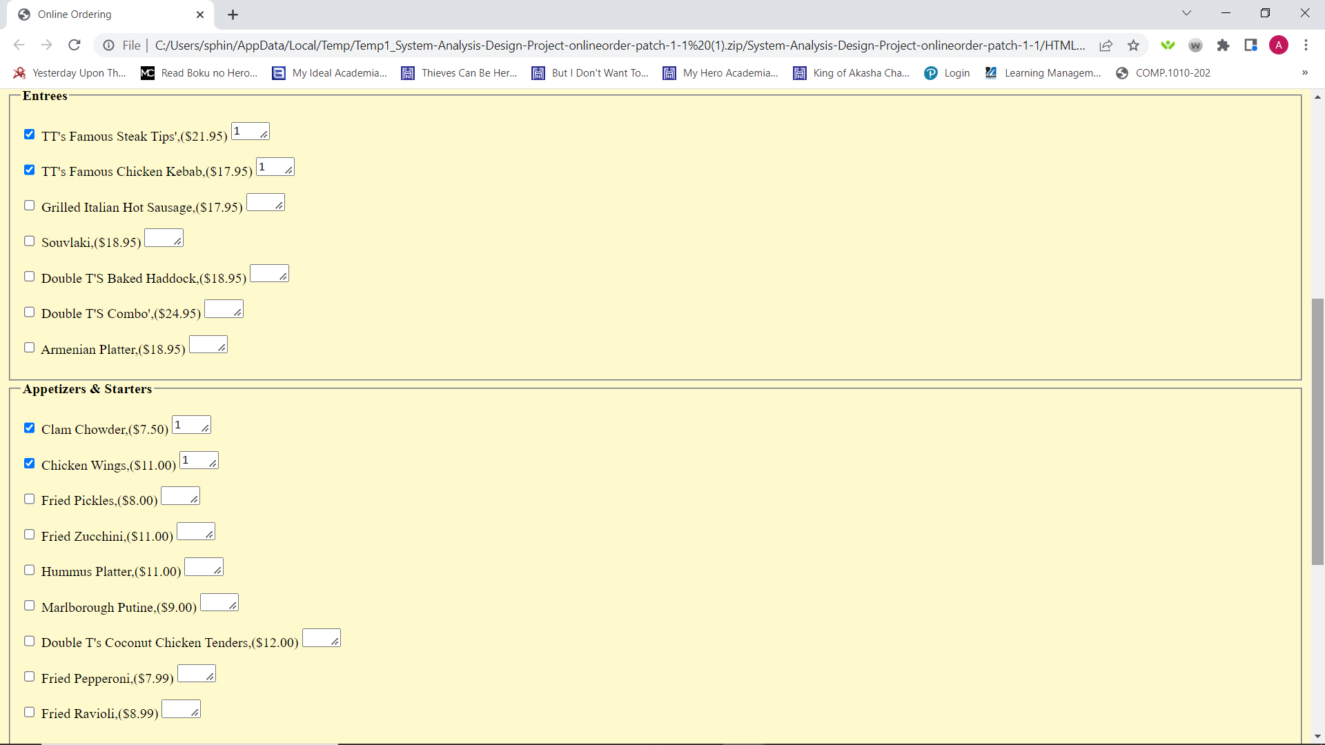

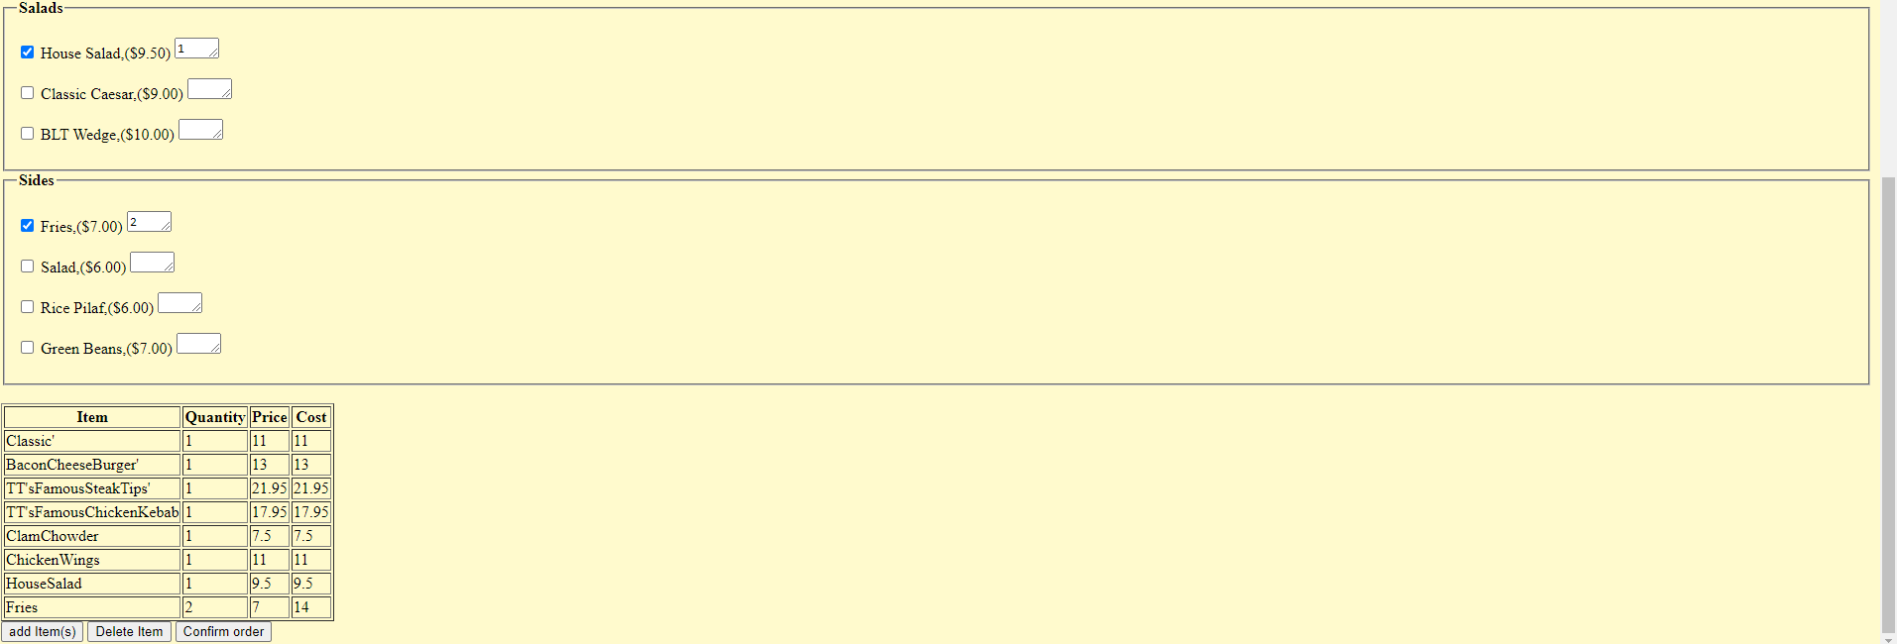

**Step 3: Once** the items the user would like to order are selected along with the desired quantities, the user can scroll to the bottom of the page and hit confirm order. This will then bring them to our payment page which collects your payment information and feedback about the use of our system.

**Step 4:**

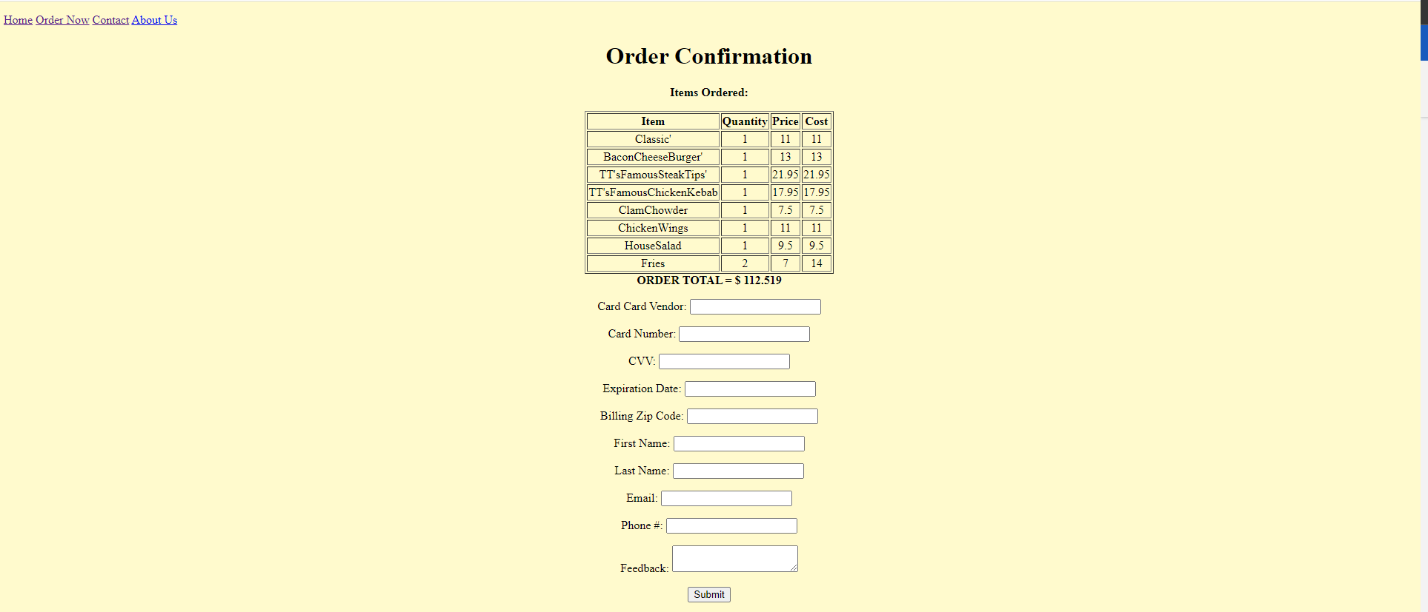

**Step 5:**



**Double T’s Tavern Database**

The database is only used for employees and managers

**Step 1:** The user will open “DOUBLE_T’S_TAVERN: Database.mdb”. The user will be greeted to an opening page that has 3 options. “Manager”, “Employee”, and “Exit Application”. Employees will only be granted access to the “Employee” option, and managers will be granted to both the “Employee” and “Manager” options.



**Step 2:** Once the user has clicked an option this will be displayed:

**Employee and Manager:** the employee will see 6 options. “Add Customer”, “Edit Existing Customer”, “Add Order”, “Add Receipt”, “Update Inventory”, and “Return to Previous Page”. The user will click on the appropriate option.



**Manager:** the manager will see 8 options. “Add Staff”, “Edit Staff”, “Edit Manager”, “Add Inventory”, “Add Payment”, “Run Inventory Report”, “Run Order Report”, and “Return to Previous Page”. The user will click the appropriate option.



**Employee and Manager**

**Step 3:** Clicking “Add Customer” will bring up a form to add customer information. The

employee will have to add a new Customer_ID, Customer First Name, Last Name, Address, City, State, Zip Code, Phone Number, Email, and a password for their account. This will add the customer to the customer table on the database. To close out of the application, right click the “Customer Information” Tab at the top of the form and click “Save” and then “Close”



**Step 4:** Clicking “Edit Existing Customer” will bring up the same form as “Add Customer”, but the user will be able to input current information for a customer and correct any field the user wanted to.



**Step 5:** Clicking “Add Order” will bring up a form and will prompt the user to input an Order_ID, Customer_ID, Staff_ID, the date of the order, the items ordered, the quantity of the products ordered, and the total of the order (multiplying the quantity by the price of the item and adding all the items and their prices together). This will append the order to the order table. To close out of the application, right click the “Order” Tab at the top of the form and click “Save” and then “Close”.



**Step 6:** Clicking “Receipt” will bring up a form for the information on a receipt. After the information from “Order” is added, it will generate a receipt and will show in this report. To close 79 out of the application, right click the “Receipt” Tab at the top of the form and click “Save” and then “Close”.



**Step 7: Click**ing “Update Inventory” will bring the user to a form that contains all information regarding the inventory. This will allow the user to update any inventory item in the database. The user will have to input a Product ID into the database and will be able to change anything about the product (most likely the quantity). To close out of the application, right click the

“Inventory” Tab at the top of the form and click “Save” and then “Close”



**Manager**

**Step 3:** Clicking “Add Staff” will bring up a form to add additional employees. The manager will have to input a new Staff_ID, the employees first and last name, their address, city, and state, the employee’s phone number, email, and password for the database. This will add a new record to the staff table. To close out of the application, right click the “Kitchen” Tab at the top of the form and click “Save” and then “Close”.



**Step 4:** Clicking “Edit Staff” will bring the manager to a form that looks the same as “Add

Staff”. This will allow the manager update information for employees by inputting the

current Staff ID, and the manager will be able to input new information for the current

staff. To close out of the application, right click the “KITCHEN Form” Tab at the top of the form and click “Save” and then “Close”.



**Step 5:** Clicking “Edit Manager” will bring the manager to a form that allows the manager to

update information about the manager. The manager must input a current Manager ID to change any information. To close out of the application, right click the “Manager” Tab at the top of the form and click “Save” and then “Close”.



**Step 6:** Clicking “Add Inventory” will bring the manager to a form that contains information

regarding an order. The manager can add new products to this form and append them to the products table. To close out of the application, right click the “Inventory” Tab at the top of the form and click “Save” and then “Close”.



**Step 7:** Clicking “Add Payment” will bring the user to a form to input information about the

payment. Since the user on the website will put their information into a third-party website to

verify the payment information, the manager will receive a transaction number (which will be

used as the Payment ID) from the third part website with the customer’s name and other

information. This information will be stored in this form. The manager will input the payment ID (the transaction number from the third-party website), the customer ID (from the customer table), and other pertinent information about the customers such as their credit card information. This will add a new record to the Payment table. To close out of the application, right click the “Payment” Tab at the top of the form and click “Save” and then “Close”.



**Step 8:** Clicking “Run Inventory Report” will bring up a report on the inventory at the store. It will display each Item ID, the name of the product, the description, the current quantity, the cost of the item, and the supplier used to buy the product. This will help the manager know when a product needs to be reordered. To close out of the application, right click the “Inventory Report” Tab at the top of the form and click “Save” and then “Close”.



**Step 9:** Clicking “Run Order Report” will bring up a report on the orders purchased through Double T’s Tavern. It will display the Order ID, the Customer ID, the Staff ID, the date the order was placed, the items ordered, the quantities, the price, and the total. To close out of the application, right click the “Order” Tab at the top of the form and click “Save” and then “Close”.



**Employee and Manager Step 10:** Clicking “Return to Main” will bring the user to the menu where the user selects “Manager”, “Employee”, or “Exit Application”. Step 11: Clicking “Exit Application” will exit out of the current database to the main menu of Microsoft Access.

**Training Material**

**User Training Seminar Schedule**

**Double T’s Tavern Online Ordering System Management Training - December 2022**

Each employee and manager will be required to complete training seminars then check off the

seminar on the agenda below and provide their initials. The employees will not have to go to

every session, it will be indicated on the schedule of days employees will have to attend the

seminars. A formal report will be provided to the corporate office at the end of each seminar.

After an employee and manager have completed the following training, they can assist other users on navigating the system and be granted administrator privileges.

**Administrating the User Training Seminar:** Dylan Gomes, Jensen Packard, Andrew Veloz – System Analysists

|  |  |  |  |
| --- | --- | --- | --- |
| **User Training Seminar** | **Date** | **Done? (Check Mark)** | **Initials** |
| Online Ordering System: Seminar 1  **Employees and Managers**  9:00AM - 1:00PM  **“Welcome Screen”** - Navigation tabs on Page **“Employee Screen”** - Navigation tabs on Page  - Add Customer - How to Add a Customer  - Add Order - How to Add an Order  - How to Save and Close Reports and Forms | December 10 |  |  |
| Online Ordering System: Seminar 2  **Employees and Managers**  9:00AM - 1:00PM  Continuation on **“Employee Screen”**  - Edit Existing Customer - How to Edit Customer Information  - Add Receipt - How to look at a Receipt for an Order  - Distribute through email or printing | December 11 |  |  |
| Online Ordering System: Seminar 3  **Employees and Managers**  9:00AM - 12:00PM  **Login Information** - permission will be granted for employees to access the Database  **Website** - Navigation, Menu, and Shopping Cart walk through | December 12 |  |  |
| Online Ordering System: Seminar 4  **Managers Only**  9:00AM - 1:00PM  **“Managers Screen”** - Navigation tabs on Page  - Add Staff - How to Add an Employee  - Add Payment - How to Enter Payment Information from Manager’s Email  - Distribute report through email or print | December 13 |  |  |
| Online Ordering System: Seminar 5  **Managers Only**  9:00AM - 1:00PM  Continuation on **“Manager Screen”**  - Run Inventory Report - How to look at the inventory report  - Distribute report through email or print  - Run Order Report - How to look at the Order Report  - Distribute report through email or print | December 16 |  |  |

**System Documents**

**Source Code**

**HomePage (HTML)**

<!DOCTYPE html>

<html>

<head>

<meta http-equiv="content-type" content="text/html; charset=UTF-8">

<title></title>

</head>

<body style=" background-color:LemonChiffon;"><br>

<h1 style=" text-align: center;"><b>Double T's Tavern</b></h1>

<p style="text-align: center;"><img src="https://scontent-bos5-1.xx.fbcdn.net/v/t39.30808-6/301778268_492671196198041_7352856424741046879_n.jpg?_nc_cat=110&ccb=1-7&_nc_sid=09cbfe&_nc_ohc=fZZelnL_23sAX8iwRWF&_nc_ht=scontent-bos5-1.xx&oh=00_AfAQGhVrD-kQpfFvuZ-lGJE2gWoFlMNJS_Vbg6Obus-Gxg&oe=638417F8"

alt="Double T's Tavern | Marlborough MA" style="width: 454px; height: 454px;"></p>

<p style="text-align: center;"><div class="topnav"> <a class="active" href="Double Ts Tavern Website.html">Home</a>

<a href="Online Ordering.html">Order Now</a> <a href="Contact.html">Contact</a> <a href="AboutUs.html">About

Us</a> </div> </p>

<div class="notification " style="-webkit-tap-highlight-color: transparent; color: rgb(32, 33, 36); font-family: Roboto, sans-serif; font-size: medium; font-style: normal; font-variant-ligatures: normal; font-variant-caps: normal; font-weight: 400; letter-spacing: normal; orphans: 2; text-align: center; text-indent: 0px; text-transform: none; white-space: normal; widows: 2; word-spacing: 0px; -webkit-text-stroke-width: 0px; text-decoration-thickness: initial; text-decoration-style: initial; text-decoration-color: initial;"><span

class="notification-content" itemprop="description" data-field="announcement"

style="-webkit-tap-highlight-color: transparent;">📍 Established 2019 l

Family Owned l Pub Style Food 🍽</span></div>

<div class="hero__strapline teQaN " data-field="hours-header" style="-webkit-tap-highlight-color: transparent; margin-bottom: 24px; color: rgb(32, 33, 36); font-family: Roboto, sans-serif; font-size: medium; font-style: normal; font-variant-ligatures: normal; font-variant-caps: normal; font-weight: 400; letter-spacing: normal; orphans: 2; text-align: center; text-indent: 0px; text-transform: none; white-space: normal; widows: 2; word-spacing: 0px; -webkit-text-stroke-width: 0px; text-decoration-thickness: initial; text-decoration-style: initial; text-decoration-color: initial;">

<div class="current-hours-content TEPfHc-R86cEd-bN97Pc temporal PTUDTb" style="-webkit-tap-highlight-color: transparent;"><br>

</div>

<div class="current-hours-content TEPfHc-R86cEd-bN97Pc temporal PTUDTb" style="-webkit-tap-highlight-color: transparent;">Find

Us On Social Media:<br>

<a href="https://www.facebook.com/DoubleTsTavern/">Facebook</a></div>

<div class="current-hours-content TEPfHc-R86cEd-bN97Pc temporal PTUDTb" style="-webkit-tap-highlight-color: transparent;"><a

href="https://www.yelp.com/biz/double-ts-tavern-marlborough">Yelp</a></div>

<div class="current-hours-content TEPfHc-R86cEd-bN97Pc temporal PTUDTb" style="-webkit-tap-highlight-color: transparent;"><a

href="https://www.instagram.com/doubletstavern/">Instagram</a></div>

</div>

<p style="text-align: center;"></p>

</body>

</html>

**Online Ordering Page (HTML)**

<!DOCTYPE html>

<html>

<head>

<meta http-equiv="content-type" content="text/html; charset=UTF-8">

<title>Online Ordering</title>

</style>

</head>

<body style=" background-color:LemonChiffon;">

<b>

<div class="topnav"> <a class="active" href="Double Ts Tavern Website.html">Home</a>

<a href="Menu.html">Menu</a>

<a href="Online Ordering.html">Order Now</a> <a href="Contact.html">Contact</a> <a href="AboutUs.html">About

Us</a> </div>

</b>

<h1 style="text-align: center;">

<b>Online Ordering</b>

</h1>

<p style="text-align: center;">

<br>

</p>

<p style="text-align: center;">

<br>

</p>

<p></p>

<!-- Start of Burgers Form-->

<form id="onlineorder">

<fieldset>

<legend>

<strong> Burger's </strong>

</legend>

<p id="q0p">

<input name="Burger" value="Classic'" type="checkbox">Classic',($11) <textarea name="quantity" id="q0"cols="3" rows="1"></textarea>

</p>

<p id="q1p">

<input name="Burger" value="Bacon Cheese Burger'" type="checkbox">Bacon Cheese Burger',($13) <textarea name="quantity" id="q1" cols="3" rows="1"></textarea>

</p>

<p id="q2p">

<input name="Burger" value="Double T's Burger'" type="checkbox">Double T's Burger',($18) <textarea name="quantity" id="q2" cols="3" rows="1"></textarea>

</p>

<p id="q3p">

<input name="Burger" value="Steak Tip Sandwich'" type="checkbox">Steak Tip Sandwich',($14) <textarea name="quantity" id="q3" cols="3" rows="1"></textarea>

</p>

<p id="q4p">

<input name="Burger" value="Double Ts Fried Chicken Sandwhich" type="checkbox">Double Ts Fried Chicken Sandwhich,($13) <textarea name="quantity" id="q4" cols="3" rows="1"></textarea>

</p>

<p id="q5p">

<input name="Burger" value="Jordan Chicken Sandwich" type="checkbox">Jordan Chicken Sandwich,($15) <textarea name="quantity" id="q5" cols="3" rows="1"></textarea>

</p>

<p id="q6p">

<input name="Burger" value="Ultimate Chicken Sandwich" type="checkbox"> Ultimate Chicken Sandwich,($17) <textarea name="quantity" id="q6" cols="3" rows="1"></textarea>

</p>

<p id="q7p">

<input name="Burger" value="Sausage Peppers + Onion Sandwhich" type="checkbox"> Sausage Peppers + Onion Sandwhich,($12) <textarea name="quantity" id="q7" cols="3" rows="1"></textarea>

</p>

</fieldset>

<!-- Start of Entrees Form-->

<fieldset>

<legend>

<strong>Entrees</strong>

</legend>

<p id="q8p">

<input name="Entree" value="TT's Famous Steak Tips'" type="checkbox"> TT's Famous Steak Tips',($21.95) <textarea name="quantity" id="q8" cols="3" rows="1"></textarea>

</p>

<p id="q9p">

<input name="Entree" value="TT's Famous Chicken Kebab" type="checkbox"> TT's Famous Chicken Kebab,($17.95) <textarea name="quantity" id="q9" cols="3" rows="1"></textarea>

</p>

<p id="q10p" >

<input name="Entree" value="Grilled Italian Hot Sausage" type="checkbox"> Grilled Italian Hot Sausage,($17.95) <textarea name="quantity" id="q10" cols="3" rows="1"></textarea>

</p>

<p id="q11p">

<input name="Entree" value="Souvlaki" type="checkbox"> Souvlaki,($18.95) <textarea name="quantity" id="q11" cols="3" rows="1"></textarea>

</p>

<p id="q12p">

<input name="Entree" value="Double T'S Baked Haddock" type="checkbox"> Double T'S Baked Haddock,($18.95) <textarea name="quantity" id="q12" cols="3" rows="1"></textarea>

</p>

<p id="q13p">

<input name="Entree" value="Double T'S Combo'" type="checkbox"> Double T'S Combo',($24.95) <textarea name="quantity" id="q13" cols="3" rows="1"></textarea>

</p>

<p id="q14p">

<input name="Entree" value="Armenian Platter" type="checkbox"> Armenian Platter,($18.95) <textarea name="quantity" id="q14" cols="3" rows="1"></textarea>

</p>

</fieldset>

<!-- Start of Appetizers & Starters Form-->

<fieldset>

<legend>

<strong>Appetizers &amp; Starters</strong>

</legend>

<p id="q15p">

<input name="Appetizer" value="Clam Chowder" type="checkbox"> Clam Chowder,($7.50) <textarea name="quantity" id="q15" cols="3" rows="1"></textarea>

</p>

<p id="q16p">

<input name="Appetizer" value="Chicken Wings" type="checkbox"> Chicken Wings,($11.00) <textarea name="quantity" id="q16" cols="3" rows="1"></textarea>

</p>

<p id="q17p">

<input name="Appetizer" value="Fried Pickles" type="checkbox"> Fried Pickles,($8.00) <textarea name="quantity" id="q17" cols="3" rows="1"></textarea>

</p>

<p id="q18p">

<input name="Appetizer" value="Fried Zucchini" type="checkbox"> Fried Zucchini,($11.00) <textarea name="quantity" id="q18" cols="3" rows="1"></textarea>

</p>

<p id="q19p">

<input name="Appetizer" value="Hummus Platter" type="checkbox"> Hummus Platter,($11.00) <textarea name="quantity" id="q19" cols="3" rows="1"></textarea>

</p>

<p id="q20p">

<input name="Appetizer" value="Marlborough Putine" type="checkbox"> Marlborough Putine,($9.00) <textarea name="quantity" id="q20" cols="3" rows="1"></textarea>

</p>

<p id="q21p">

<input name="Appetizer" value="Double T's Coconut Chicken Tenders" type="checkbox"> Double T's Coconut Chicken Tenders,($12.00) <textarea name="quantity" id="q21" cols="3" rows="1"></textarea>

</p>

<p id="q22p">

<input name="Appetizer" value="Fried Pepperoni" type="checkbox"> Fried Pepperoni,($7.99) <textarea name="quantity" id="q22" cols="3" rows="1"></textarea>

</p>

<p id="q23p">

<input name="Appetizer" value="Fried Ravioli" type="checkbox"> Fried Ravioli,($8.99) <textarea name="quantity" id="q23" cols="3" rows="1"></textarea>

</p>

</fieldset>

<!-- Start of Salads Form-->

<fieldset>

<legend>

<strong>Salads</strong>

</legend>

<p id="q24p">

<input name="Salad" value="House Salad" type="checkbox"> House Salad,($9.50) <textarea name="quantity" id="q24" cols="3" rows="1"></textarea>

</p>

<p id="q25p">

<input name="Salad" value="Classic Caesar" type="checkbox"> Classic Caesar,($9.00) <textarea name="quantity" id="q25" cols="3" rows="1"></textarea>

</p>

<p id="q26p">

<input name="Salad" value="BLT Wedge" type="checkbox"> BLT Wedge,($10.00) <textarea name="quantity" id="q26" cols="3" rows="1"></textarea>

</p>

</fieldset>

<!-- Start of Sides Form-->

<fieldset>

<legend>

<strong>Sides</strong>

</legend>

<p id="q27p">

<input name="Sides" value="Fries" type="checkbox"> Fries,($7.00) <textarea name="quantity" id="q27" cols="3" rows="1"></textarea>

</p>

<p id="q28p">

<input name="Sides" value="Salad" type="checkbox"> Salad,($6.00) <textarea name="quantity" id="q28" cols="3" rows="1"></textarea>

</p>

<p id="q29p">

<input name="Sides" value="Rice Pilaf" type="checkbox"> Rice Pilaf,($6.00) <textarea type="number" name="quantity" id="q29" cols="3" rows="1"></textarea>

</p>

<p id="q30p">

<input name="Sides" value="Green Beans" type="checkbox"> Green Beans,($7.00) <textarea name="quantity" id="q30" cols="3" rows="1"></textarea>

</p>

</fieldset>

<br>

<table border = 1 id="ordertbl">

<tr>

<th>Item</td>

<th>Quantity</td>

<th>Price</td>

<th>Cost</td>

</tr>

</table>

<button type="button" onclick="get_order()"> add Item(s) </button>

<button type="button" onclick="del_tbl()">Delete Item</button>

<button type="button" onclick="confirm_order(food_order)">Confirm order</button>

<!-- End of the Forms-->

</form>

<!--Retrieve user form input-->

<script src="get_order"></script>

</body>

</html>

**Order Confirmation Page (HTML)**

<!DOCTYPE html>

<html>

<head>

<meta http-equiv="content-type" content="text/html; charset=UTF-8">

<title></title>

</head>

<style>

table.center {

margin-left: auto;

margin-right: auto;

}

</style>

<body style=" background-color:LemonChiffon;" onload="retrieve_ls()">

<p> </p>

<div class="topnav"> <a class="active" href="Double Ts Tavern Website.html">Home</a>

<a href="OnlineOrdering.html">Order Now</a> <a href="Contact.html">Contact</a> <a href="AboutUs.html">About

Us</a> </div>

<div style="text-align: center;">

<h1><b>Order Confirmation</b></h1>

</div>

<div style="text-align: center;">

<p><b> Items Ordered: </b></p>

</div>

<p></p>

<div style="text-align:center">

<table border = 1 id="ordertbl" class="center">

<tr>

<th>Item</td>

<th>Quantity</td>

<th>Price</td>

<th>Cost</td>

</tr>

</table>

<b>ORDER TOTAL = $</b>

<b id ='total'>0</b>

<form id ='paymentinfo'>

<p>Card Card Vendor: <input type="text"></input></p>

<p>Card Number: <input type="text"></input></p>

<p>CVV: <input type="text"></input></p>

<p>Expiration Date: <input type="text"></input></p>

<p>Billing Zip Code: <input type="text"></input></p>

</form>

<form id ='custinfo'>

<p>First Name: <input type="text"></input></p>

<p>Last Name: <input type="text"></input></p>

<p>Email: <input type="text"></input></p>

<p>Phone #: <input type="text"></input></p>

<p>Feedback: <textarea type="text"></textarea></p>

</form>

<button type="button" onclick="clear_ls()">Submit</button>

</div>

<script src="get_order"></script>

</body>

</html>

**Contact Us (HTML)**

<!DOCTYPE html>

<html>

<head>

<meta http-equiv="content-type" content="text/html; charset=UTF-8">

<title></title>

</head>

<body style="background-color:LemonChiffon;">

<p> </p>

<div class="topnav"> <a class="active" href="Double Ts Tavern Website.html">Home</a>

<a href="Online Ordering.html">Order Now</a> <a href="Contact.html">Contact</a> <a href="AboutUs.html">About

Us</a> </div>

<h1> </h1>

<h1 style="text-align: center;">Contact Us</h1>

<p style="text-align: center;"> <a href="tel:+1-508-485-0007"> <button>Call

Us!</button><br>

</a></p>

<h2 style=" text-align: center;">Address</h2>

<p style="text-align: center;"> <a href="https://www.google.com/maps/dir//Double+Ts+Tavern/data=%214m8%214m7%211m0%211m5%211m1%211s0x89e38b15aa19981b:0x1a1603500957b827%212m2%211d-71.5495712%212d42.3461668">

<button>Directions</button><br>

</a></p>

<h2 style=" text-align: center;">Business Hours</h2>

<table style="border:1px solid black;margin-left:auto;margin-right:auto;">

<tbody>

<tr>

<td style="text-align: center;">Monday</td>

<td style="text-align: center; height: 20px;"><span style="color: rgb(32, 33, 36); font-family: Roboto, sans-serif; font-size: medium; font-style: normal; font-variant-ligatures: normal; font-variant-caps: normal; font-weight: 400; letter-spacing: normal; orphans: 2; text-align: start; text-indent: 0px; text-transform: none; white-space: nowrap; widows: 2; word-spacing: 0px; -webkit-text-stroke-width: 0px; text-decoration-thickness: initial; text-decoration-style: initial; text-decoration-color: initial; display: inline !important; float: none;">2:30

– 9:30 PM</span></td>

</tr>

<tr>

<td style="width: 71.517px; text-align: center;">Tuesday</td>

<td style="width: 294.483px; text-align: center;"><span style="color: rgb(32, 33, 36); font-family: Roboto, sans-serif; font-size: medium; font-style: normal; font-variant-ligatures: normal; font-variant-caps: normal; font-weight: 400; letter-spacing: normal; orphans: 2; text-align: start; text-indent: 0px; text-transform: none; white-space: nowrap; widows: 2; word-spacing: 0px; -webkit-text-stroke-width: 0px; text-decoration-thickness: initial; text-decoration-style: initial; text-decoration-color: initial; display: inline !important; float: none;">2:30

– 9:30 PM</span></td>

</tr>

<tr>

<td style="text-align: center;">Wednesday</td>

<td style="text-align: center;"><span style="color: rgb(32, 33, 36); font-family: Roboto, sans-serif; font-size: medium; font-style: normal; font-variant-ligatures: normal; font-variant-caps: normal; font-weight: 400; letter-spacing: normal; orphans: 2; text-align: start; text-indent: 0px; text-transform: none; white-space: nowrap; widows: 2; word-spacing: 0px; -webkit-text-stroke-width: 0px; text-decoration-thickness: initial; text-decoration-style: initial; text-decoration-color: initial; display: inline !important; float: none;">2:30

– 9:30 PM</span></td>

</tr>

<tr>

<td style="text-align: center;">Thursday</td>

<td style="text-align: center;"><span style="color: rgb(32, 33, 36); font-family: Roboto, sans-serif; font-size: medium; font-style: normal; font-variant-ligatures: normal; font-variant-caps: normal; font-weight: 400; letter-spacing: normal; orphans: 2; text-align: start; text-indent: 0px; text-transform: none; white-space: nowrap; widows: 2; word-spacing: 0px; -webkit-text-stroke-width: 0px; text-decoration-thickness: initial; text-decoration-style: initial; text-decoration-color: initial; display: inline !important; float: none;">2:30

– 9:30 PM</span></td>

</tr>

<tr>

<td style="text-align: center;">Friday</td>

<td style="text-align: center;"><span style="color: rgb(32, 33, 36); font-family: Roboto, sans-serif; font-size: medium; font-style: normal; font-variant-ligatures: normal; font-variant-caps: normal; font-weight: 400; letter-spacing: normal; orphans: 2; text-align: start; text-indent: 0px; text-transform: none; white-space: nowrap; widows: 2; word-spacing: 0px; -webkit-text-stroke-width: 0px; text-decoration-thickness: initial; text-decoration-style: initial; text-decoration-color: initial; display: inline !important; float: none;">2:30

– 9:30 PM</span></td>

</tr>

<tr>

<td style="text-align: center;">Saturday</td>

<td style="text-align: center;"><span style="color: rgb(32, 33, 36); font-family: Roboto, sans-serif; font-size: medium; font-style: normal; font-variant-ligatures: normal; font-variant-caps: normal; font-weight: 400; letter-spacing: normal; orphans: 2; text-align: start; text-indent: 0px; text-transform: none; white-space: nowrap; widows: 2; word-spacing: 0px; -webkit-text-stroke-width: 0px; text-decoration-thickness: initial; text-decoration-style: initial; text-decoration-color: initial; display: inline !important; float: none;">2:30

– 9:30 PM</span></td>

</tr>

<tr>

<td style="text-align: center;">Sunday</td>

<td style="text-align: center;">Closed</td>

</tr>

</tbody>

</table>

<p style="text-align: center;"><img src="https://lh3.googleusercontent.com/p/AF1QipMIuTGR0mrZ0oAGsPBwUrzRHSCXdFdPkBw567B4=w1080-h608-p-no-v0"

alt="Header image for the site"> </p>

</body>

</html>

**About Us (HTML)**

<!DOCTYPE html>

<html>

<head>

<meta http-equiv="content-type" content="text/html; charset=UTF-8">

<title></title>

</head>

<body style=" background-color:LemonChiffon;">

<p> </p>

<div class="topnav"> <a class="active" href="Double Ts Tavern Website.html">Home</a>

<a href="Online Ordering.html">Order Now</a> <a href="Contact.html">Contact</a> <a href="AboutUs.html">About

Us</a> </div>

<div style="text-align: center;">

<h1><b>About Us</b></h1>

</div>

<div style="text-align: center;">

<p><b> Double T's Tavern is a Family Owned, Pub Style Food Resturant that was Established in 2019. We are currently located on Weed St. in Marlborough Massachusetts and directions to our resturant can be found on our Contact Page. </b></p>

</div>

<p></p>

<img src="https://scontent-bos5-1.xx.fbcdn.net/v/t39.30808-6/305488484_492671199531374_8618488640489194138_n.jpg?_nc_cat=108&ccb=1-7&_nc_sid=e3f864&_nc_ohc=Oi0e8Cl4KqAAX-NEXgg&_nc_ht=scontent-bos5-1.xx&oh=00_AfCDRDdzYTDHbblGVNLeceVzGimr6lnHGQkZlm858kOqpg&oe=6380FDFD">

</body>

</html>

**Get Order JavaScript (JavaScript)**

var food_order = [];

function get_order() {

var all = document.querySelectorAll("#onlineorder input, #onlineorder textarea");

for (var i = 0; i < all.length; i++) {

if (all[i].checked && all.length > 0) {

let key = 'q' + i / 2; //key to access quantity id

let key_p = key + 'p'; //key to access <p> menu item

let quantity = document.getElementById(key).value;

let menu_item = document.getElementById(key_p).textContent;

menu_item = menu_item.replace(/\s+/g, ''); //removes whitespace from grabbed item

let menu_array = menu_item.split(','); //splits by , delim

menu_array[1] = menu_array[1].replace('(', '').replace(')', '').replace('$', '');

quantity = parseFloat(quantity);

menu_array[1] = parseFloat(menu_array[1]);

quantity_cost = quantity * menu_array[1];

food_order.push([menu_array[0], quantity, menu_array[1], quantity_cost]); //push order onto stack

}

}

console.log('Item,Quantity,price,quantity-price');

for (var j = 0; j < food_order.length; j++)

console.log(food_order[j]);

get_total(food_order);

}

function get_total(food_order) {

let total = 0;

if (food_order.length >= 0) {

for (let i = 0; i < food_order.length; i++) {

total += food_order[i][3];

}

console.log('TOTAL ORDER COST =', '$', total);

for (let i = 0; i < food_order.length; i++) {

insert_tbl(food_order[i]);

}

window.localStorage.setItem('total', total)

}

}

function insert_tbl(food_order) {

var tbl = document.getElementById('ordertbl');

var row = tbl.insertRow();

var item_c = row.insertCell();

var quantity_c = row.insertCell();

var price_c = row.insertCell();

var cost_c = row.insertCell();

item_c.innerHTML = food_order[0];

quantity_c.innerHTML = food_order[1];

price_c.innerHTML = food_order[2];

cost_c.innerHTML = food_order[3];

}

function del_tbl() {

var tbl = document.getElementById('ordertbl');

var rows = tbl.rows.length - 1;

if (rows > 0) {

tbl.deleteRow(rows);

}

food_order = food_order.splice(0,rows-1); //removes item last added

}

function confirm_order(food_order){

window.localStorage.setItem('order', JSON.stringify(food_order));

location.href = "Orderconfirmation.html";

}

function retrieve_ls(){

order = JSON.parse(window.localStorage.getItem('order'));

for (let i = 0; i < order.length; i++) {

insert_tbl(order[i]);

}

total = parseFloat(window.localStorage.getItem('total'));

total *= 1.0625;

document.getElementById('total').innerText = total.toFixed(3);

}

function clear_ls(){

window.localStorage.clear();

window.location.reload();

}

**Python Application (Python)**

"""

Created on Thu Nov 17 11:25am 2022

@authors: Dylan Gomes & Jensen Packard

"""

# Initalize Variables

menu_items = ['Classic','Bacon Cheese Burger','Double Ts Burger','Steak Tip Sandwich','Double Ts Fried Chicken Sandwhich','Jordan Chicken Sandwich','Ultimate Chicken Sandwich','Sausage Peppers + Onion Sandwhich','TTs Famous Steak Tips','TTs Famous Chicken Kebab','Grilled Italian Hot Sausage','Souvlaki','Double TS Baked Haddock','Double TS Combo','Armenian Platter','Clam Chowder','Chicken Wings','Fried Pickles','Fried Zucchini','Hummus Platter','Marlborough Putine','Double Ts Coconut Chicken Tenders','Fried Pepperoni','Fried Ravioli','House Salad','Classic Caesar','BLT Wedge','Fries','Salad','Rice Pilaf','Green Beans']

# Application Design

print("#"*30+"\n Welcome to Double Ts Tavern\n"+"#"*30+ \

"\nPlease Chose your Order:")

# Declare Variables

menu_prices = {"Classic":11.00,

"Bacon Cheese Burger":13.00,

"Double Ts Burger":18.00,

"Steak Tip Sandwich":14.00,

"Double Ts Fried Chicken Sandwhich":13.00,

"Jordan Chicken Sandwich":15.00,

"Ultimate Chicken Sandwich":17.00,

"Sausage Peppers + Onion Sandwhich":12.00,

"TTs Famous Steak Tips":21.95,

"TTs Famous Chicken Kebab":17.95,

"Grilled Italian Hot Sausage":17.95,

"Souvlaki":18.95,

"Double TS Baked Haddock":18.95,

"Double TS Combo":24.95,

"Armenian Platter":18.95,

"Clam Chowder":7.50,

"Chicken Wings":11.00,

"Fried Pickles":8.00,

"Fried Zucchini":11.00,

"Hummus Platter":11.00,

"Marlborough Putine":9.00,

"Double Ts Coconut Chicken Tenders":12.00,

"Fried Pepperoni":7.99,

"Fried Ravioli":8.99,

"House Salad":9.50,

"Classic Caesar":9.00,

"BLT Wedge":10.00,

"Fries":7.00,

"Salad":6.00,

"Rice Pilaf":6.00,

"Green Beans":7.00}

# Show all menu items

for item,price in menu_prices.items():

print(str(menu_items.index(item))+': ' + item.title()+" - Price: $"+str(price))

print('#'*30)

# Add items

x = True

total_price = 0 # total price

orders = [] # store selected items

while x:

order = input("Enter Item Number, If multiple; followed by the quantity separated by a comma:")

print("To finish your order type 'done', to view current order type 'show'")

ord_split = order.split(',')

if ord_split[0].isnumeric():

items = menu_items[int(ord_split[0])]

else:

items = order

x = items

if x == 'done':

x = False

elif x == 'show':

print('current order:',orders)

elif len(ord_split) > 1:

quantity = int(ord_split[1])

for i in range(quantity):

orders.append(items)

total_price +=(menu_prices[items])

else:

total_price += (menu_prices[items])

orders.append(items)

print(items, 'added')

print('#'*30)

state_tax = 1.0625

# Final Total

print("Items in your cart: ")

for i in range(len(orders)):

print(str(i+1)+" - "+orders[i].title() +" - $"+str(menu_prices[orders[i]]))

print("Your Total Price: "+'$'+str(total_price*state_tax))

#End

print('#'*30+"\nThanks! Order Again.\n")

**Technical Report**

**How we will address technical support for Double T’s Tavern**

We plan on creating a means to track problems within the system and log these issues, it will track how much progress has been made, and assign system bugs and change requests. To ensure no redundant or harmful changes are made the reports for the systems will include:

* The current version of our systems, so we can confirm if it was an error carried over from a previous version or if it’s the fault of a change we made
* A means to track if it was somewhere in the database or website that was causing problems
* Track which customer or employee may have caused the issue to see if there was something wrong with the data inputted into the system that caused the problem
* How severe the problem is to the system so we can better prioritize which problems we are encountering and what issues we should be addressing and looking at first to create possible solutions
* And should anyone fix the issue before we can address it to potential gain some insight into making a solution and fixing the system so the issue won’t happen again

The team is also planning on providing support for an optional annual charge, including the price of the Online Ordering System, which will allow our users to call our hotline support number or submit an online request for more expediated help.

**Maintenance Request Form**

Double T’s Tavern

REQUESTED BY ____________________________________________________________

DEPARTMENT ___________________________ DATE: _________________________

LOCATION ____________________________________________________________

CONTACT ____________________________________________________________

TYPE OF REQUEST:

[ ] Immediate [ ] Operations are impaired or opportunity lost

[ ] System Enhancement [ ] Problems exists but can be worked around

[ ] System Error Correction [ ] Business losses can be tolerated until

system is fixed

PROBLEM:

SERVICE REQUEST:

IS LIAISON Thomas Peretzian Jr. (Tel-508-485-0007 e-mail: Tperetzian@Dttavern.com)___

SPONSER Adam Sandler Sales Manager___________________________

- - - - - - - - - - - - - - - - - - - TO BE COMPLETED BY SYSTEMS PRIORITY BOARD - - - - - - - - - - - - - - - -

[ ] Request Approved Assigned to: ____________________________

[ ] Recommend revision Start Date: _____________________________

[ ] Suggest user development

[ ] Reject for reason.

_____________________________________________________

_____________________________________________________

**Maintenance Manual**

**Type of Maintenance Approximate Percentage of Effort**

Corrective

*Error messages don’t display or aren’t displaying properly* 50%

Adaptive

*Update the Database/Website quarterly* 20%

Perfective

*Enhance and update picture to keep with modern standards* 15%

*Add other means of e-commerce payment methods*

*Update Layout to modern standards*

Preventive 15%

*Increase # of orders system it able to process*

*Ensure security standards to stop a potential data breach*

*Increase masking capabilities of database*

**Testing Data**

Double T’s Tavern Online Ordering System was tested with some test data to ensure that all systems were functioning properly and accepting and saving the data they should be.

The first form that was tested in our database was the Customer Information to allow an employee to add and edit a customer in the database.

This is adding the customer:

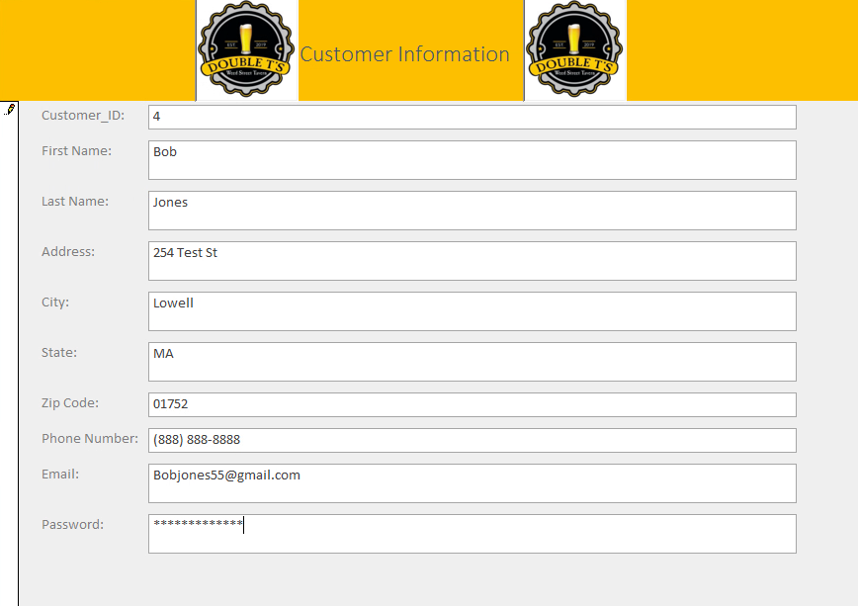

The added information is then properly inserted into the table:

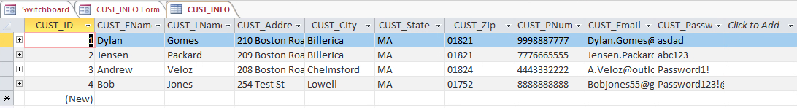

The edit form properly shows all 4 customers in the table to edit and has no errors when changing customer information:

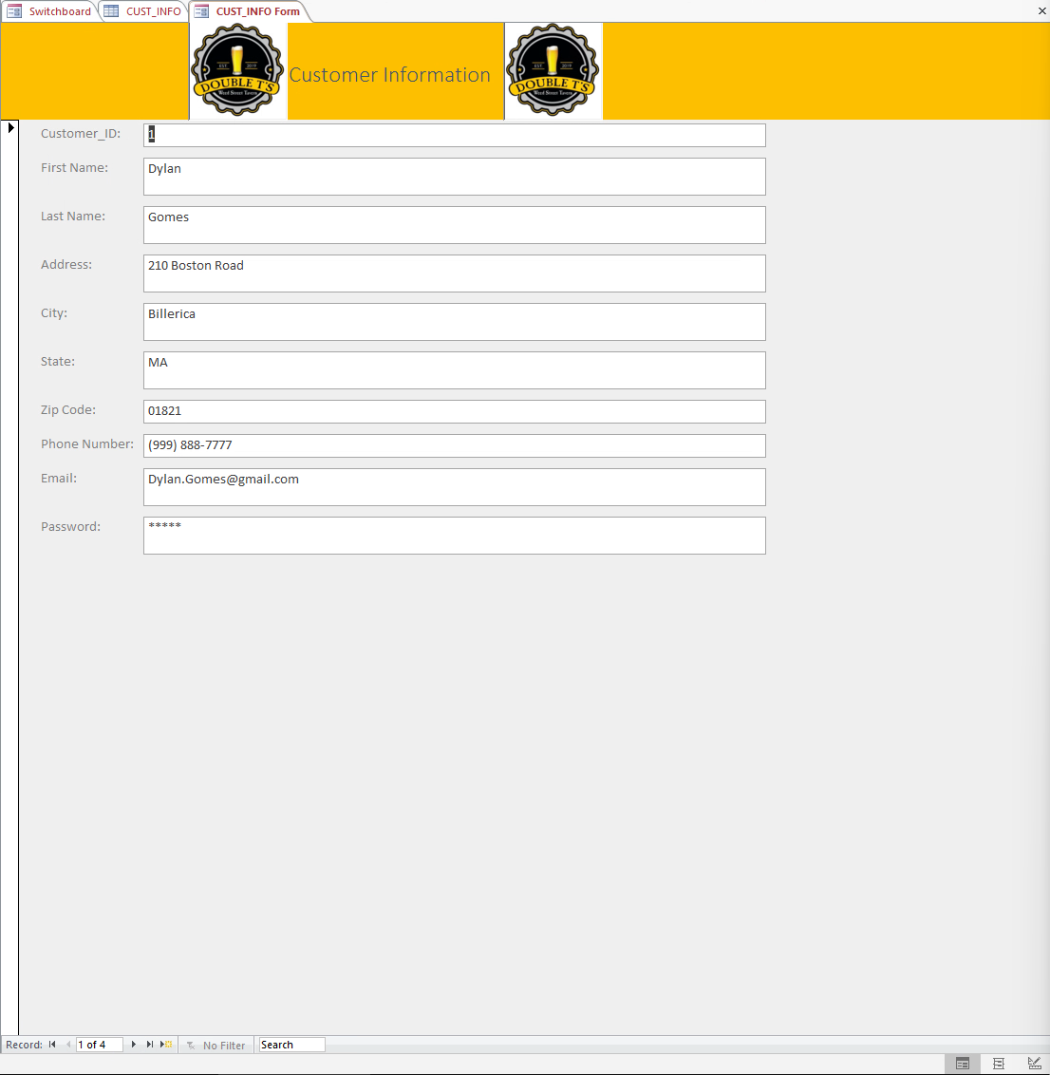

Next is an employee being able to add an order to the system through the order form:

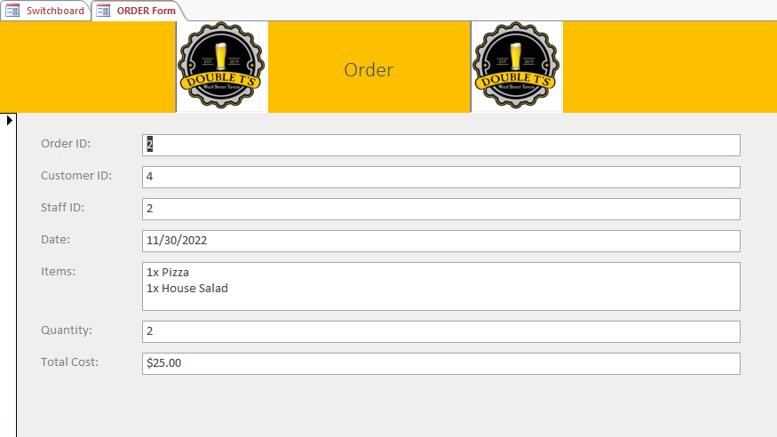

As we can see from the Order table all the information from the order form has transferred properly:

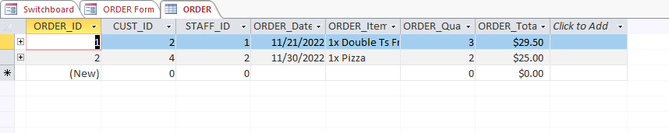

Next the Employee must be able to add a receipt into the system:

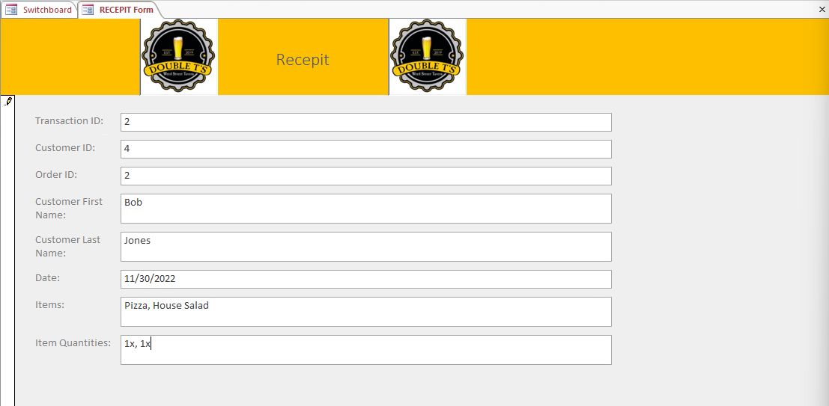

The data correctly moved over with no errors:

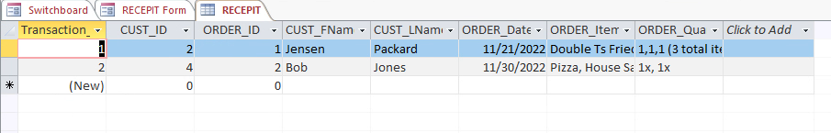

Lastly the employee must be able to update inventory information:

Original:

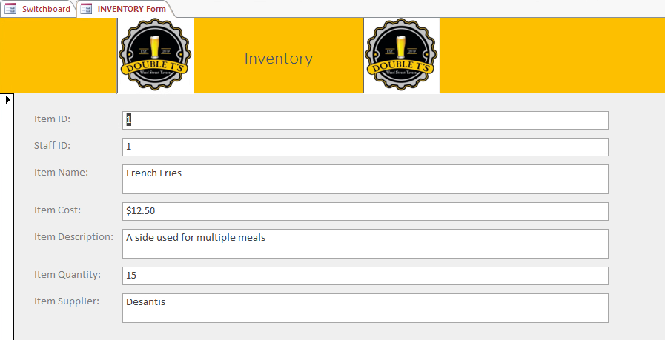

Updated Inventory:

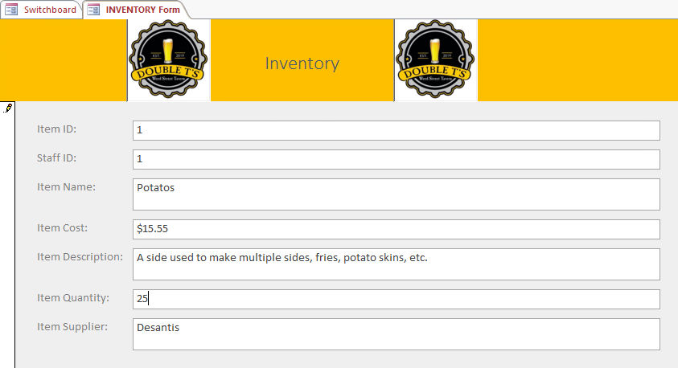

The data properly updated in the table with no errors:

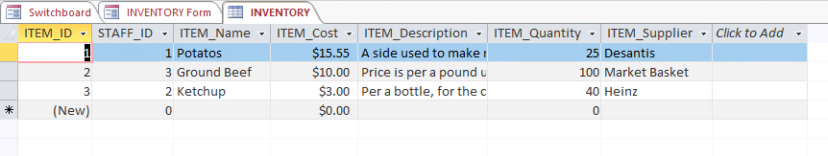

This section is now for the Manager section of the database, starting out with the ability to be able to add and edit staff members:

This is a manager adding a new staff member through the proper form:

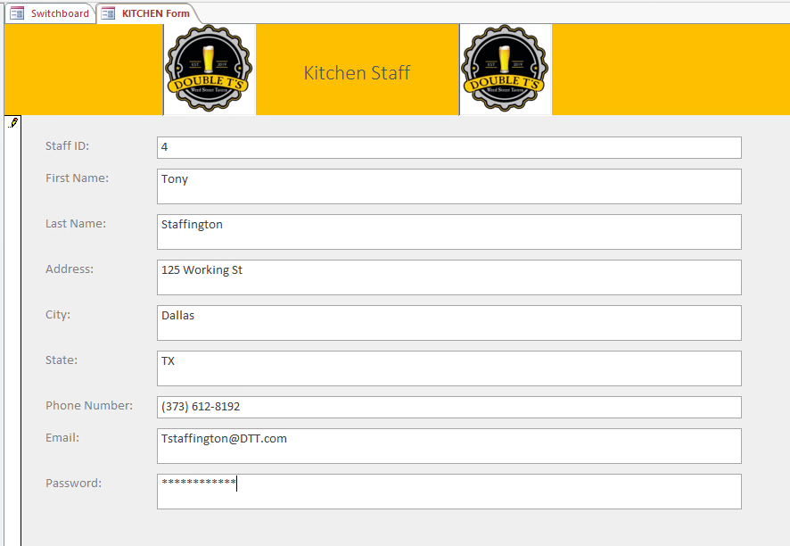

The data was properly added to the table with no errors:

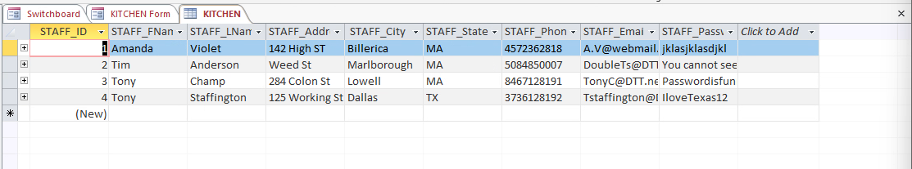

The edit form properly shows all 4 customers in the table to edit and has no errors when changing customer information:

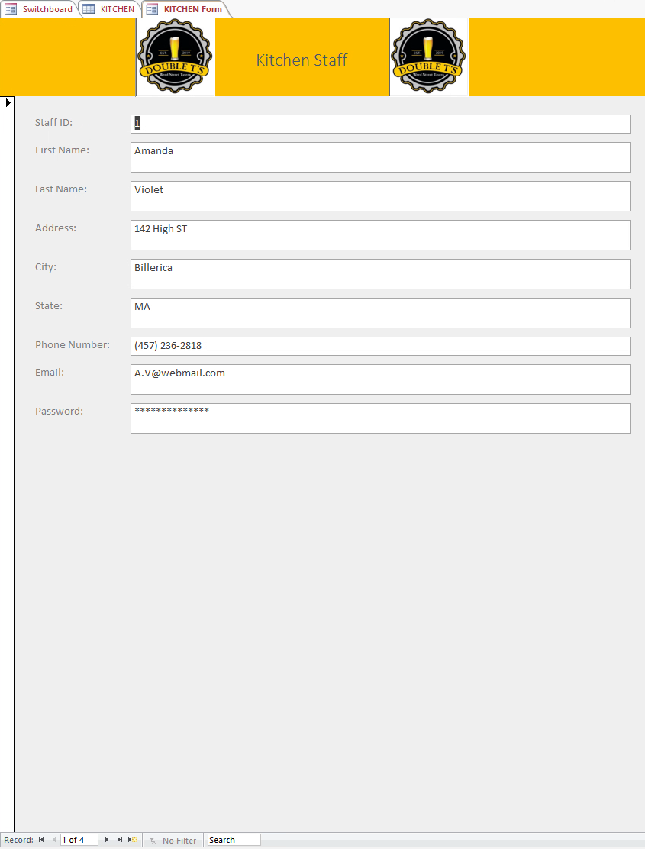

Next, we must ensure that Management can make the proper edits to managers as need be:

Currently there is only one manager to make changes to:



Through the form the proper adjustments have been made to the manager:

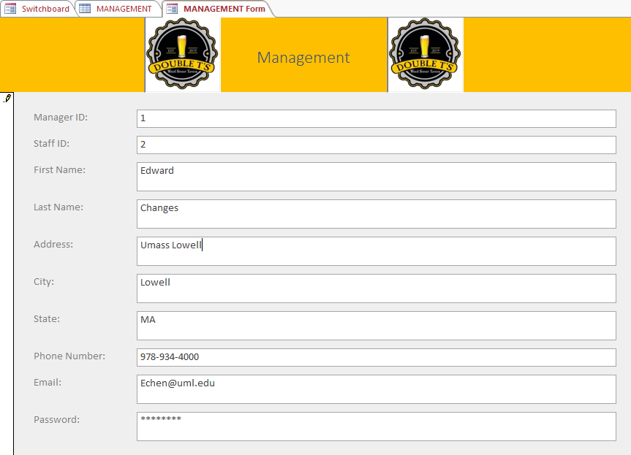

The data properly edited in the table with no errors:



Next the managers must be able to add the new inventory from shipments as they come in:

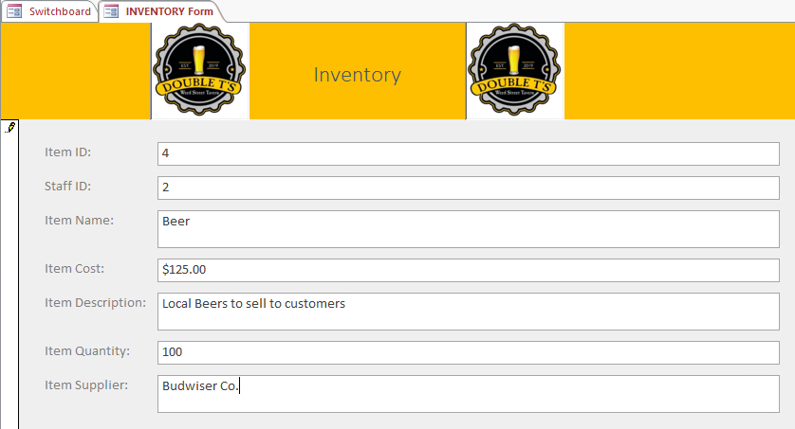

The data was properly added with no errors:

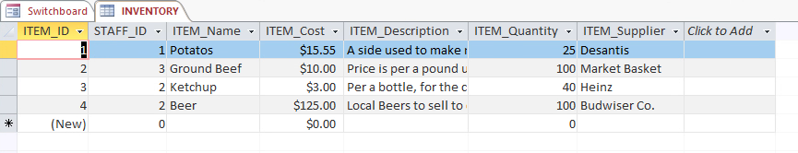

Next the managers need to be able to add payment information into the system:

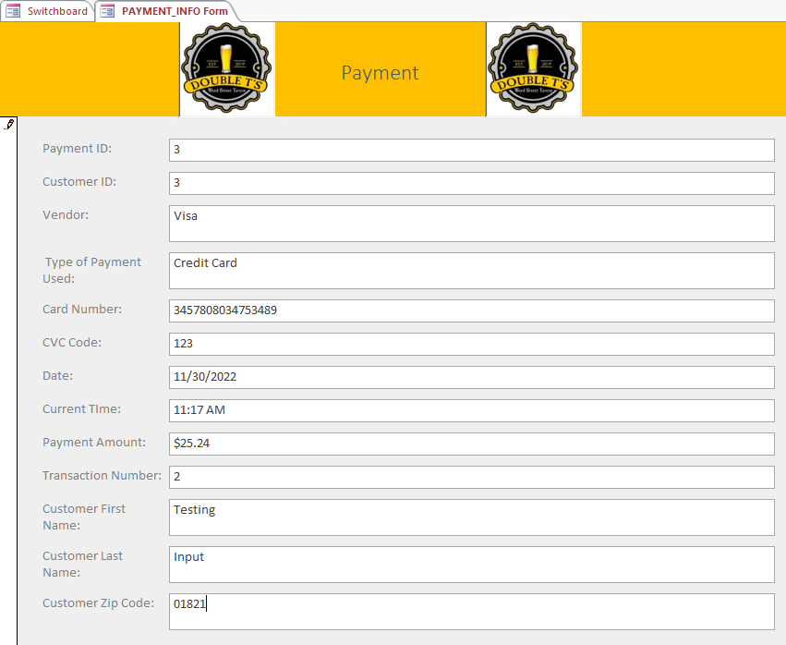

The card information was added properly to the table with no errors:

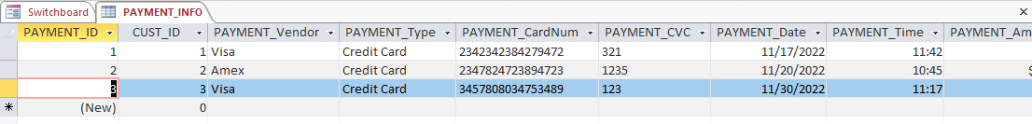

Finally, the managers need to be able to run both the Inventory report and the Order report:

Inventory Report: (Ran with no errors and is not missing any information)

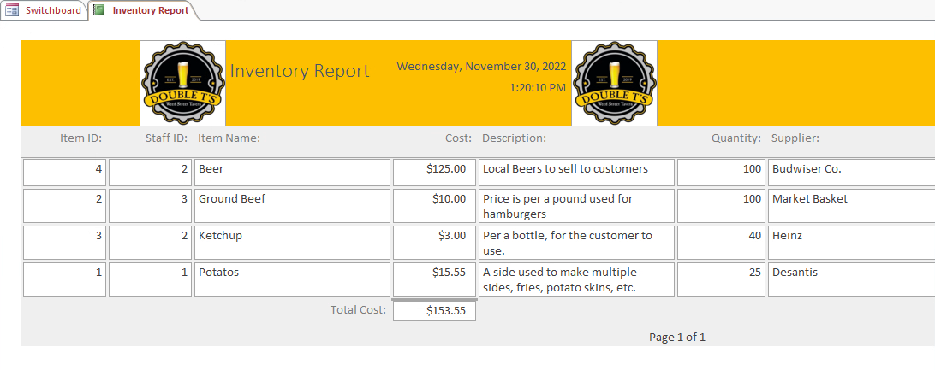

Order Report: (Ran with no errors and is not missing any information)

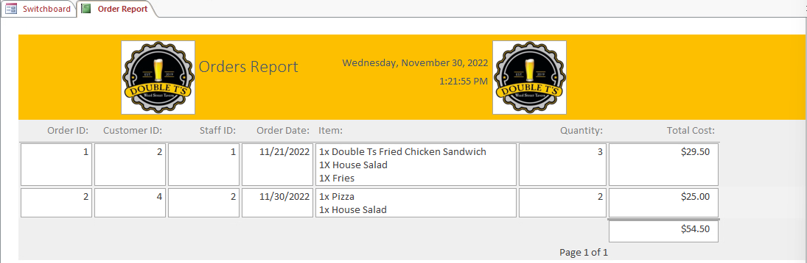

Finally, this is the result of our Python application for a simulation of our shopping cart, this calculates the total cost of items with the tax and has no errors:

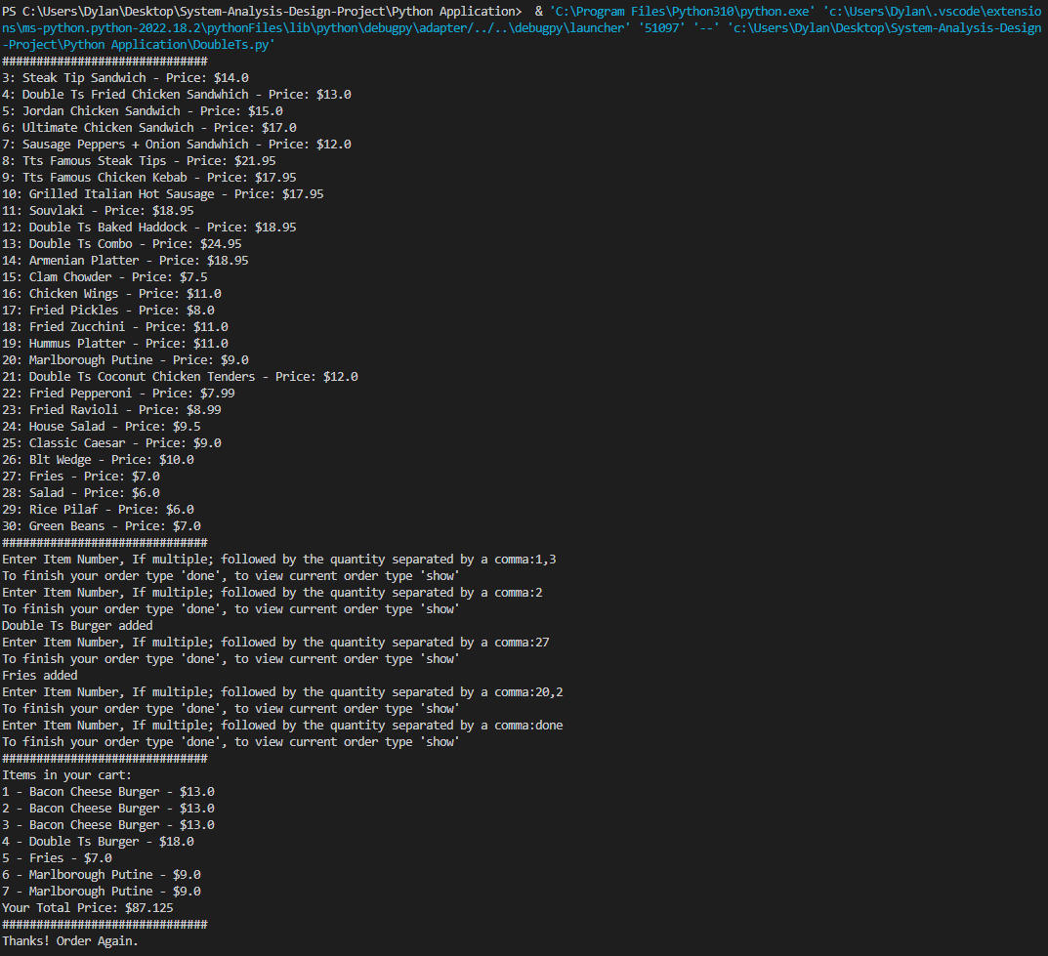

**Errors in the System:**

Out of our entire system there was only three known errors found, considering the system has not been deployed yet we can and will ensure these errors will be fixed before the system release. The first error is on the homepage of the website, the links to the other pages are supposed to be centered but are not centered properly. The second error is also on the webpage currently for the online web ordering it current is not very secure, the information could be easily grabbed in its basic HTML state so that needs to be fixed before the final launch. The final error is that the webpage doesn’t properly sync to the access database, and this will also be fixed before the final release.

**Milestone 1 and 2 Grade Sheets**

